- Introduction
- Background Information
  - Location of Mt. Everest
  - Geography of the Surrounding Area
  - Facts about Mt. Everest
    - Height of the mountain
    - How the mountain was named
      - Peak XV
      - Joloungma (Tibetan name)
      - Sagarmatha (Nepalese name)
    - The number of people who have climbed Everest to date
- Major Explorers Covered in this Paper
  - Sir Edmund Hillary
    - First to reach the summit (1953)
    - Led a team of experienced mountain climbers who worked together
  - Tenzing Norgay and the Sherpas
    - Norgay was an experienced climber and guide who accompanied Hillary
    - Sherpas still used to guide expeditions
  - Rob Hall
    - Leader of the failed 1996 expedition
    - Led group of (mainly) tourists with little mountain climbing experience
- The Impact Expeditions have had on Mt. Everest and Local Community
  - Ecological Effects
    - Loss of trees due to high demand for wood for cooking and heating for tourists.
    - Piles of trash left by climbing expeditions
  - Economic Effects
    - Expedition fees provide income for the country
    - Expeditions provide work for the Sherpas, contributing to the local economy.
  - Cultural Effects
    - Introduction of motor vehicles
    - Introduction of electricity
- Conclusion

General Information

Sanskrit and Nepali Sagarmatha, Tibetan Chomolungma, Chinese (Pinyin) Zhumulangma Feng, or (Wade-Giles romanization) Chu-mu-lang-ma Feng, also spelled Qomolangma Feng mountain on the crest of the Great Himalayas of southern Asia that lies on the border between Nepal and the Tibet Autonomous Region of China, at 27°59¢ N, 86°56¢ E.

- Reaching an elevation of 29,035 feet (8,850 metres), Mount Everest is the highest mountain in the world, the highest point on Earth.

- Like other high peaks in the region, Mount Everest has long been revered by local peoples; its most common Tibetan name, Chomolungma, means “Goddess Mother of the World” or “Goddess of the Valley.”

- The Sanskrit name Sagarmatha means literally “Ocean Mother.” Its identity as the highest point on the Earth's surface was not recognized, however, until 1852, when the governmental Survey of India established that fact.

- In 1865 the mountain—previously referred to as Peak XV—was renamed for Sir George Everest, British surveyor general of India from 1830

- Physical Features
- Everest is composed of multiple layers of rock folded back on themselves (nappes). Rock on the lower elevations of the mountain consists of metamorphic schists and gneisses, topped by igneous granites. Higher up are found sedimentary rocks of marine origin (remnants of the ancient floor of the Tethys Sea that closed after the collision of the two plates). Notable is the Yellow Band, a limestone formation that is prominently visible just below the summit pyramid.

- Everest is shaped like a three-sided pyramid. The three generally flat planes constituting the sides are called faces, and the line by which two faces join is known as a ridge. The North Face rises above Tibet and is bounded by the North Ridge (which meets the Northeast Ridge) and the West Ridge; key features of this side of the mountain include the Great and Hornbein couloirs (steep gullies) and the North Col at the start of the North Ridge.

- The summit of Everest itself is covered by rock-hard snow surmounted by a layer of softer snow that fluctuates annually by some 5–20 feet (1.5–6 metres); the snow level is highest in September, after the monsoon, and lowest in May after having been depleted by the strong northwesterly winter winds.

- Lack of oxygen, powerful winds, and extremely cold temperatures preclude the development of any plant or animal life there.

- Climate
- The climate of Everest is always hostile to living things. The warmest average daytime temperature (in July) is only about -2 °F (-19 °C) on the summit; in January, the coldest month, summit temperatures average -33 °F (-36 °C) and can drop as low as -76 °F (-60 °C). Storms can come up suddenly, and temperatures can plummet unexpectedly.

- The peak of Everest is so high that it reaches the lower limit of the jet stream, and it can be buffeted by sustained winds of more than 100 miles (160 km) per hour.

- Precipitation falls as snow during the summer monsoon (late May to mid-September). The risk of frostbite to climbers on Everest is extremely high.

- Exploration

Beginning with the British expeditions of the early 20th century, surveying and portering work became available. Eventually, the respect and pay earned in mountaineering made it attractive to the Sherpas, who, being so well adapted to the high altitudes, were capable of carrying large loads of cargo over long distances.

Though Sherpas and other hill people (the name Sherpa came to be applied—erroneously—to all porters) tend to outperform their foreign clients, they typically have played a subordinate role in expeditions; rarely, for example, has one of their names been associated with a pioneering route on Everest.

The influx of foreign climbers—and, in far greater numbers, trekkers—has dramatically changed Sherpa life, as their livelihood increasingly has come to depend on these climbing expeditions.

- "Everest, Mount." Encyclopædia Britannica. Encyclopædia Britannica Online School Edition. Encyclopædia Britannica, 2009. Web. 1 Dec. 2009 <http://www.school.eb.com/eb/article-234720>.

- National Geographic Article on Mt. Everest http://adventure.nationalgeographic.com/everest.html

- The Explorer’s Web
- http://www.mounteverest.net/

- 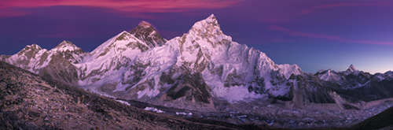

- http://search.ebscohost.com/login.aspx?direct=true&db=imh&AN=imh539917&site=ehost-live

- 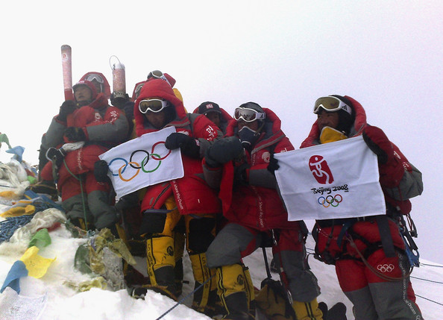

- http://search.ebscohost.com/login.aspx?direct=true&db=imh&AN=imh444448&site=ehost-live

- 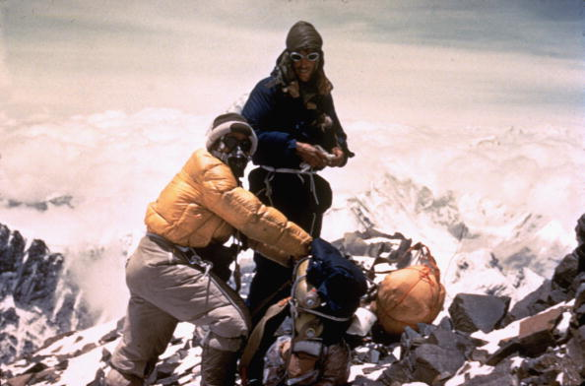

- http://search.ebscohost.com/login.aspx?direct=true&db=imh&AN=imh211267&site=ehost-live

- 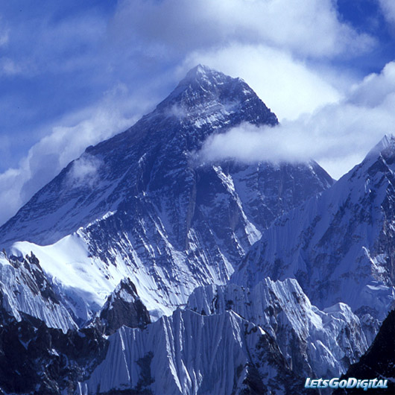

- http://www.letsgodigital.org/images/artikelen/39/mount-everest.jpg

