**Kamehameha Schools Maui High School Store**

-

**Ke Kuʻono**

**School Year 2012-2013**

*\*Limited Sizes & Colors*

**CLOTHING:**

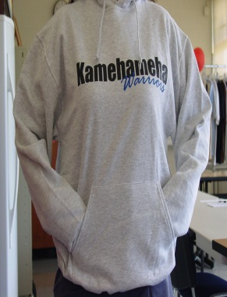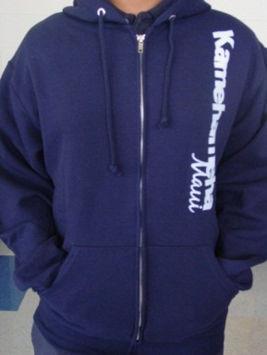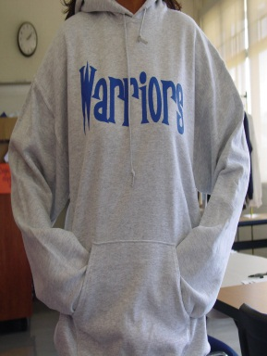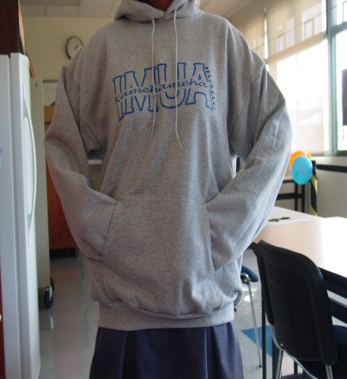

**JACKETS -**

*\*Limited Sizes & Colors*

KS Maui Sweat - $25

(WHT, GRY)

IMUA Sweat - $25

(WHT, BRNN, NVY, GRY)

Warrior Sweat - $25

(WHT, GRY)

Zip Warriors - $30

(WHT, NVY, GRY)

KS Sweat - $25

(BL, P, BR, GRY)

****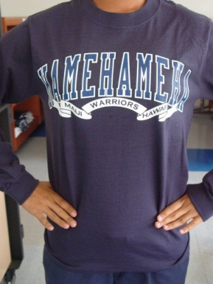

**LONG SLEEVE SHIRTS -**

*\*Limited Sizes & Colors*

ʻIke Pono - $11.00

(NVY, GRY SIZE SMALL ONLY)

Ribbon L/S Tee - $11.00 (GRY SIZE SMALL ONLY)

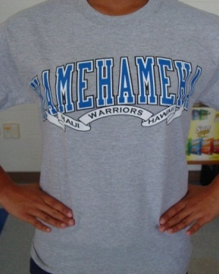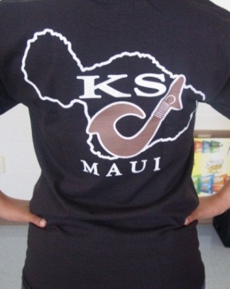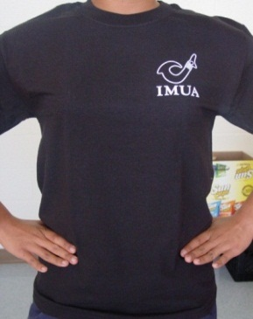



**SHIRTS -**

*\*Limited Sizes & Colors*

Ribbon - $8.00

(NVY, GRY)

Hook - $8.00

(BR, BLK, WHT)

Pride - $8.00 (GRY, WHT)

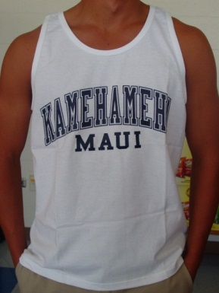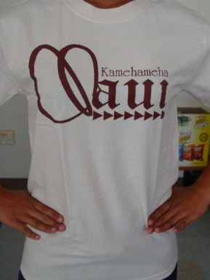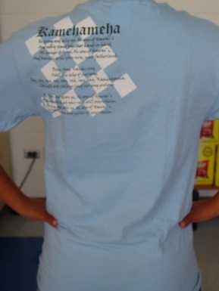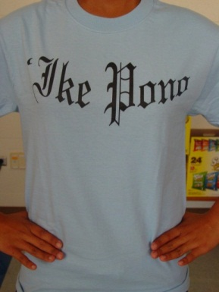

**SHIRTS -**

*\*Limited Sizes & Colors*

Tank Tops - $5.00

(WHT, NVY)

(SMALL, XXL)

Maui - $8.00

(BGE, NVY, GRY)

ʻIke Pono - $8.00 (BL, NVY, GRY)

**LOGO MERCHANDISE -**

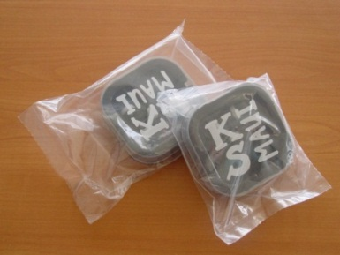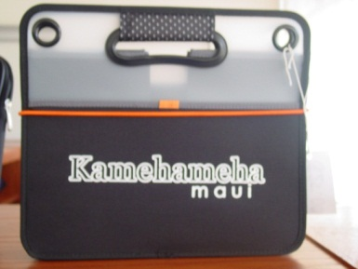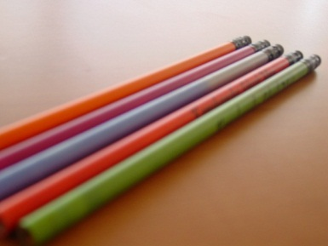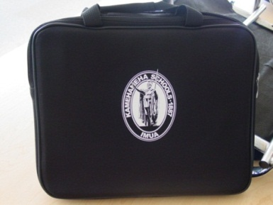

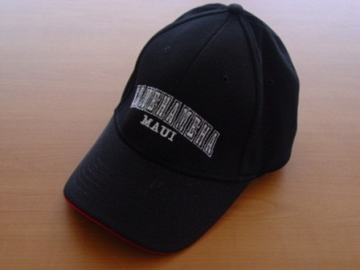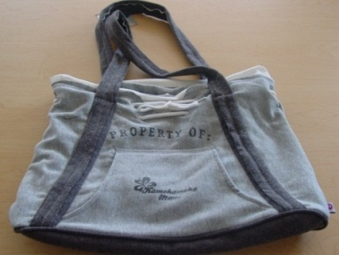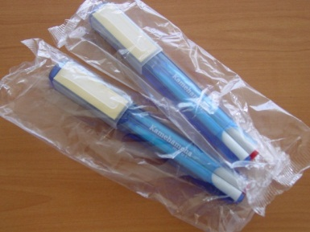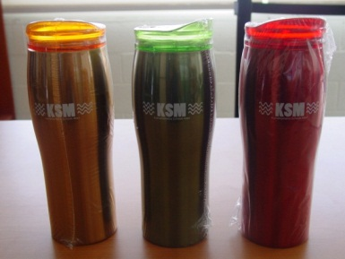

Cargo Organizer - $25.00

14in. x 12in.

Mood Pencils - $0.75

KS Earbuds - $5.00

Mug - $5.00

Computer Bag - $20.00

13in. x 11in.

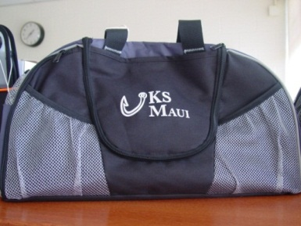

Duffle - $20.00

(GRY, BLK)

18in. x 10in. x 10in.

Baseball Cap - $15.00

Hoodie Tote - $35.00

17in. x 12 in.

Twin Set - $2.00

Travel Mug - $10.00

* 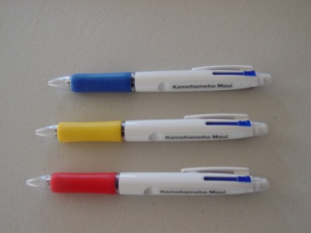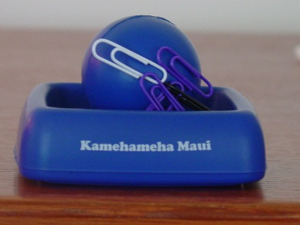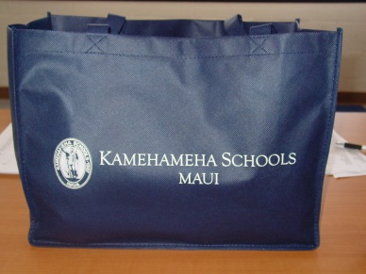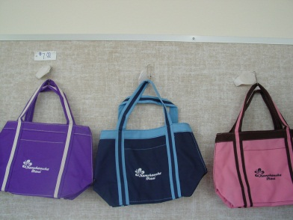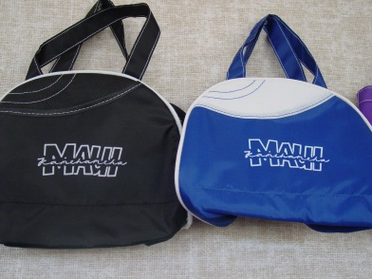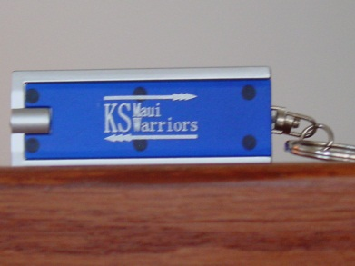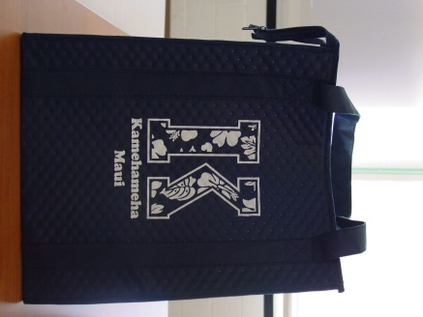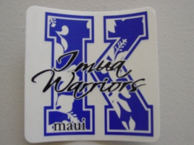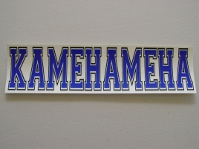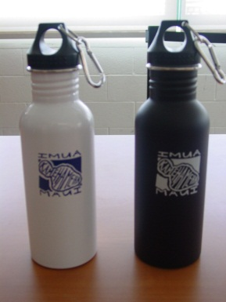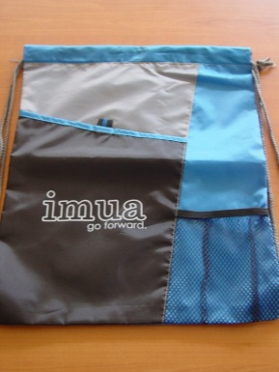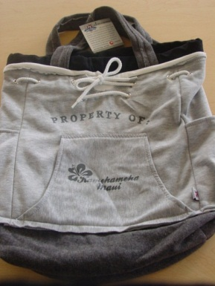

Tote - $7.00

12in. x 8in

Lunch Tote - $7.00

10in. x 8in.

Recycled Bag - $2.00

15.5in. x 12in.

Paper Clip Holder - $5.00

3in. x 3in.

3-in-1 Pen - $2.00

Hoodie Backpack - $35.00

13in. x 17in.

Thermo Bag - $9.00

15in. x 13in. x 10in

Key Chain Light - $3.00

Shoe Bag - $6.00

13in. x 15in.

“K” Sticker - $1.50

$2.00

$2.00

Stainless Steel Water Bottle - $10.00