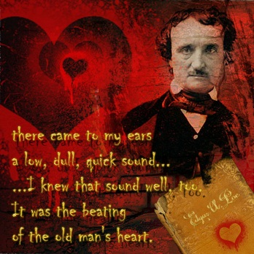Vocabulary for “A Tell-tale Heart”

**Preview this vocabulary** before you read or listen to the story, and be prepared- I will quiz you on it to make sure you have done this!. . Use it for future reference when you are doing the related assignments. This short story was first published in 1843, so the narration may be a little different from what you’re used to.

**1. Foresight**: thoughtful regard for the future   
  
**2. Dissimulation**: a form of deception where one hides the truth; to disguise one’s true feelings under a fake appearance.  
  
**3. Vexed**: troubled, distressed, agitated

**4. Sagacity**: wise, solid judgment

**5. Hearkening**: giving careful attention

**6. Awe**: a mixed feeling of reverence, fear, and wonder

**7. Acute**: having a very keen awareness

**8. Waned**: to become gradually less

**9. Scantlings**: small quantities or amounts

**10. Suavity**: having smooth politeness and being persuasively pleasing

**11. Bade**: past tense of “bid” – to utter or summon

**12. Audacity**: bold courage, fearless daring

**13. Reposed**: to lay at rest

**14. Derision**: contempt, ridicule

**15. Dissemble**: to disguise or conceal behind a false appearance