Art Multimedia & Design
1 credit/Semester Daily

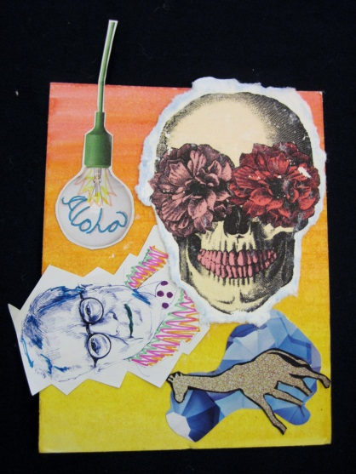

Artwork: Brenden Uemura-Asao c/o 2014 Olivia Iaea c/o 2014

Instructor: Lori W Guntzel
Email address loguntze@ksb.edu
Phone number 573-7012

Classroom X 109
Office hours: most days @ lunch and after school 2:30-3:30

Course Description:

This is a foundational course for students to explore techniques in both two-dimensional
and three-dimensional design. Students will learn drawing and painting skills, relief printing, as well as basic concepts of sculpture. The language of art as defined by the Art Elements and Design Principles, exploration of visual culture and identity will be covered through these various media as a means of visual communication.

Student Learning Expectations:

Students will learn how to use a variety of both two-dimensional and three-dimensional media such as charcoal, pastel, collage, paint, printmaking, clay, mesh, wire, plaster and recycled materials (trash) to name a few. Students will also learn how to use proper art tools to create a variety of projects that will include at least two kinds of media. Projects will be complex and will require planning and research.

Course outline
The following projects will be explored:

-Basic Drawing Techniques -Art Elements & Design Principles

-Painting Project (Special Places) -Color Wheel

-Ceramics : basic hand building - Relief Printing: cultural relief print

-T-Shirt Stencil -Mixed Media: sculpture & collage

-Artist Trading Cards -Wire sculpture, Papier Mache
Resources:

While we don’t have a textbook, we will be using our library resources as well as current online and print ideas/articles. Introduction to new projects will be done with power point and class discussion. There will also be the occasional guest artist demonstration.

Grading:
75% of your grade is based on assigned projects. 25% of your grade is based on written assignments, participation, and cleaning up.
* Unacceptable written work will be required to be repeated for a lesser grade.

Make-ups: Due to absences for whatever reason, it is the student’s responsibility for completion.

Late Projects: For each day that your project is late, you will be graded down one letter grade.

Extra Credit: There is no extra credit for this course.

Expected classroom behaviors:
- Aloha: treat other with respect
- Kuleana: Be here on time and ready to learn, and complete your projects on time
- Ho’omau: Active participation in class activities
- Ha’aha’a: offer help when needed and be able to take constructive criticism
- ‘Ike Pono: Shares ideas and insights to class; practices Hawaiian and Christian values.
- Malama: Takes care of classroom and art supplies
- Imi Na Auao: Utilizes class time effectively

*Cell Phones: There are only tow instances when you should have them out: a. to listen to music, and b. to get a photo for reference. If you have them out for any other reason, I will confiscate them until the end of the day.

*Bathroom “breaks”: Use them only if you need to; daily “breaks” are suspicious and will be grounds for a referral and or conference.

If you need to talk to me:
Please don’t hesitate to ask me for help! If we can’t solve it during class, please see me during my office hours: most lunches and after school from 2:30-3:30.

Please sign and return to teacher:

Class Protocol Agreement

Students are not allowed to use their laptops for any purpose other than class work. If students are using their laptops for gaming, chatting, or other activities not related to their classwork, their computers will be confiscated by the teacher. Students may have their parents/guardians pick up their computers at the end of the day between 2:30-3:30 p.m. or in the morning between 7:30-7:45 a.m. (Mon-Fri.). Please contact teacher in advance for pick-up.

Students are to abide by classroom rules and are responsible for cleaning up the art studio. Failure to do so may result in points deducted from assignments.

ACKNOWLEDGEMENT:

I have read and understand the terms and conditions of this class and agree to abide by the expectations set forth.

__________________________________ ___________________________________
Student’s Name Printed Block

____________________________ ______________________________
Student’s Signature Parent/Guardian Signature

