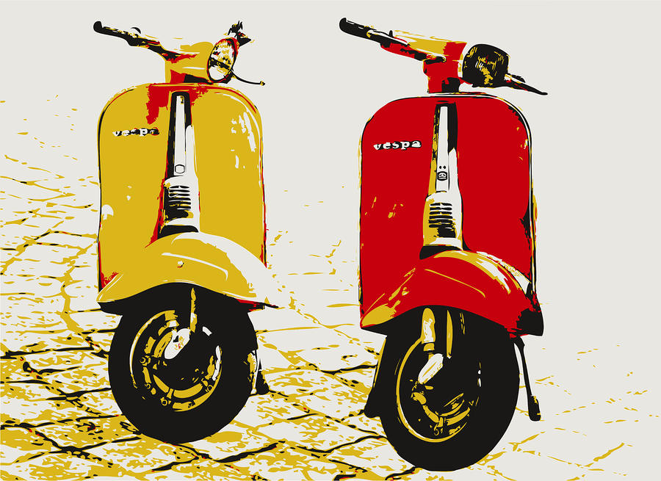

Instructor: Lori W-Guntzel
Room: Kekaulike X-109
Phone: 573-7012
Email: loguntze@ksbe.edu
Office Hours: Tues, Thurs & Fri or by appointment
Art History
A year-long course that meets every other day (1 credit)

Prerequisites: None

Student Learning Outcomes:

This course will focus on a historical survey of the visual arts. Foundational concepts, critical examination of various art styles/movements, and understanding of aesthetic principles will be explored. Students will engage in projects that further enhance their awareness of visual communication in relationship to time, place, and culture. We will also have Socratic Seminar style discussions for each unit.

Major texts, literature, or resources:
Various online and printed sources (included in classroom/CRB learning center); Art in Focus by Mittler; Art Through the Ages by Gardner. Gateways to Art by DeWitte, Larmann & Shileds

Course outline (subject to change):
VI. Art & Religion
A. Christian, Byzantine, Islamic
B. Medieval
C. Gothic
VII. Modern Europe
A. Renaissance
B. Baroque
C. Rococo
VIII. Art of the 19th & 20th Century
A. Impressionism
B. Cubism
C. Abstract Expressionism
D. Pop Art
E. Post Modern Art
I. Introduction to a Visual Vocabulary
- Elements/Principles of Art
II. Art Criticism & Aesthetics
- What makes art, art?
III. Ancient World
A. Egyptian Art
B. Greek & Roman Art
IV. Non-Western World
A. India, China, Japan
B. Native Americans
C. Oceana

Grading:
Projects & Classwork 40%
Performance Tests/Quizzes/Papers 60%
*All late work is marked down one grade for each day that it is late

Attendance, participation, and work make-up policy:
Students will be assigned daily participation points that are worked into the overall grade. If a student has an excused absence then missed work is due within one week of the student’s return.

Expected classroom behaviors:
PRACTICE “LIVING PONO” DAILY
ALOHA: Treat others properly and respectfully.
KULEANA: Prepared to learn and completes assignments on time.
HOÿOMAU: Actively participates in classroom activities.
HAÿAHAÿA: Offers help when needed and grateful for others’ help.
ÿIKE PONO: Shares ideas and insights with class; practices Hawaiian and Christian values.
MÄLAMA: Takes care of classroom and art supplies.
ÿIMI NA ÿAUAO: Utilizes class time effectively.

Supplies:
1- 3 ringed binder for notes and projects

Please sign and return this lower portion to teacher ART HISTORY Class Protocol Agreement
Students are not allowed to use their laptops for any purpose other than class work. If students are using their laptops for gaming, chatting, or other activities not related to their class work, their computers will be confiscated by the teacher. Students may have their parents/guardians pick up their computers at the end of the day between 2:30 – 3:30 p.m. or in the morning between 7:30 – 7:45 a.m. (Mon. – Fri.) Please contact teacher in advance for pick-up.

Students are to abide by classroom rules or may have points deducted from assignments.

ACKNOWLEDGEMENT:

I have read and understood the terms and conditions of this class and agree to abide by the expectations set forth.

________________________________________________ _____________________________________
Student’s Name Printed Block

___________________________________________ ____________________________________________
Student’s Signature Parent/Guardian’s Signature

