Ceramics & Sculpture I

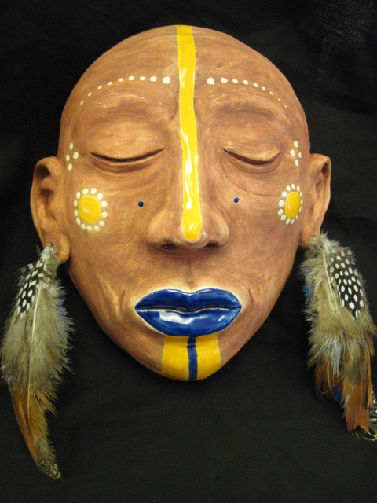
Mask: Lily Higashino c/o 2014

Instructor:
Lori W Guntzel

Email address: loguntze@ksb.edu

Phone number:
573-7012

Classroom X 109

Office hours: Tues. & Fri. 2:30-3:30

Course Description:

Ceramics and Sculpture I introduces foundational studio skills in designing three-dimensional art works, including ceramics (fired clay). Various three-dimensional media (non-clay) processes will be introduced using art styles that are realistic in representation to interpretive abstractions. Art appreciation, history and theory will be woven into 3D projects that are integrative, inspire creativity, and develop problem solving skills.
Student Learning Expectations:

Students will learn how to work with clay as well as other materials, ceramic tools and equipment. Students are expected to learn basic safety procedures in the ceramic classroom as they learn a variety of sculpting and hand-building techniques. Skills such as hand-building, sculpting, slab-work and wheel throwing are introduced in Ceramics & Sculpture I.

Course outline: Ceramics & Sculpture I

- What is Ceramics? Introduction to materials, techniques and ceramic processes
-Introduction to Ceramic Equipment, Classroom Safety Procedures
- Pinch Pot Sculptures
-How to work with basic sculpting method of pinching clay and attaching pieces

III Sculpting using subtractive method: Puzzle Box
-How to make a solid sculpture and remove clay

Sculpting using additive and subtractive methods: Masks

- Tiles
-How to make slabs into tiles
-Introduction to relief, how to incorporate texture into your art

- Miter Myth Boxes
-How to build with slabs
-Incorporating a story on your 3-D piece

- Coil Pots
-How to attach coil to make a vessel
-Smoothing the inside for strength

- Making vases: large coil method

- Wheel Throwing
-Basic wheel throwing techniques

Grading:

75% of your grade is based on each assigned project. 25% of your grade is based on written assignments, class participation and cleaning up.
* Any written assignment that is turned unacceptable will be repeated for less credit.
Make-ups: Due to absences for whatever reason, it is the student’s responsibility for completion.
Late Projects: For each day that your project is late, you will be graded down one letter grade.
Extra Credit: There is no extra credit for this course.

Expected classroom behaviors:

- Aloha: treat other with respect
- Kuleana: Be here on time and ready to learn, and complete your projects on time
- Ho’omau: Active participation in class activities
- Ha’aha’a: offer help when needed and be able to take constructive criticism
- ‘Ike Pono: Share ideas and insights to class; practice Hawaiian and Christian values.
- Malama: Takes care of classroom and art supplies

*Cell Phones: The only times when you may have your phone out is: a. to listen to music or B. to get a picture for reference. If you use it for any other reason I will confiscate it until the end of the day.

*Bathroom Breaks: Please go before class; otherwise use them wisely. Excessive “breaks” will be considered suspicious and grounds for referral and/or conference.

*If you need to come in for a advice or just to work more on your piece, you may do so at lunch time or after school if I am not in a meeting.
**You are expected to clean up after yourself, and if this becomes a problem, you may have this privilege revoked.

Lastly, ceramics and sculpture is a fun! My expectations are high for all of my students, and even if you do not take this class seriously, I do! In order to excel at it, you must practice and not give up. I will do everything in my power to help you create successful projects, but I will never do them for you. Art is considered by many to be the fun, fluffy subject in school, but it can be extremely challenging for some while for others it seems to come easy. For all of my students, going through the process of creating a successful piece of art will help you in many other subject areas. Please don’t compare yourself to anyone else over the period of this course; measure your success by how you improve over time and let’s have a great year!

-Mrs. G

Please sign and return to teacher:
-----------------------------------------------------------------------------------------------------------------
Class Protocol Agreement
Students are not allowed to use their laptops for any purpose other than class work. If students are using their laptops for gaming, chatting, or other activities not related to their classwork, their computers will be confiscated by the teacher. Students may have their parents/guardians pick up their computers at the end of the day between 2:30-3:30 p.m. or in the morning between 7:30-7:45 a.m. (Mon-Fri.). Please contact teacher in advance for pick-up.

Students are to abide by classroom rules and are responsible for cleaning up the art studio. Failure to do so may result in points deducted from assignments.

ACKNOWLEDGEMENT:

I have read and understand the terms and conditions of this class and agree to abide by the expectations set forth.

__________________________________ ___________________________________
Student’s Name Printed Block

____________________________ ______________________________
Student’s Signature Parent/Guardian Signature

