Video 1
Advanced Camera Project

CREW: __________________________________________ Period: ________________
_________________________________________Camera/SD # ___________

STORYBOARD your shots BEFORE going out to shoot using RULE OF THIRDS.
Plan your LOCATIONS, TALENT, PROPS & CREW in advance.
Each person must serve as Director, Camera, and Talent at least once.
DO NOT ZOOM IN AND OUT during your shots!

Your grade will be affected by:

1. Correct slate for shots.
2. Doing atleast 2 takes for each shot.
3. Using a tripod to steady shots.
4. Hold shots for atleast 10 secs for editing.
5. Follow storyboard.
6. Framing & Composition – rule of thirds

Materials:
Talent 1: Talent 2: Talent 3: Talent 4:

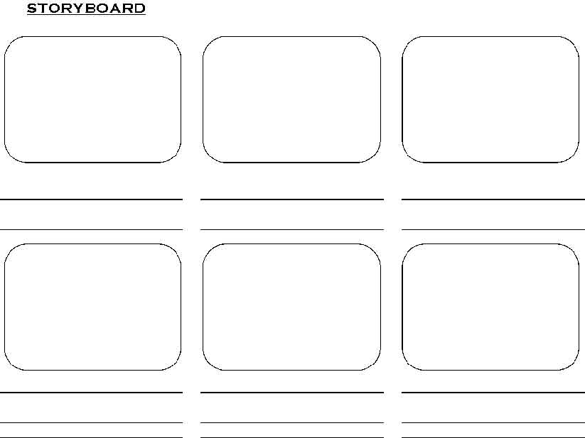
Scene 1 - Talent 1 walks in from outside of a room, sits down to read then falls asleep
Shot 1: WS Talent 1 walks into a doorway from outside of a room
Director:
Camera:
Talent 1:
First AD(slate):
Location:

Shot 1a: MS Talent 1 walks inside a room through a doorway, sits down, opens a book, flip pages, reads, then leans over and falls asleep.
Director:
Camera:
Talent 1:
First AD(slate):

Shot 1b: OTS MCU Talent 1 opens book, flip pages, reads, leans over and falls asleep
Director:
Camera:
Talent 1:
First AD(slate):

Scene 2 , Shot 2– WS face of the clock
Director:
Camera:
First AD(slate):
Location:

Scene 3 - Talent 2 & 3 talk to each other
Shot 3: MW2S Talent 2 & 3 talk to each other, Talent 2 lifts hand to drink from cup, puts hand down, lifts hand to drink again, brings hand
down as realize cup is empty, turns cup upside down.
Talent 3 points and laughs at the cup, Talent 2 reacts sadly.
Director:
Camera:
Talent 2 & 3:
Location:

Shot 3a: MCU Talent 2 lifts hand to drink again, brings hand down as realize cup is empty, turns cup upside down, reacts with a sad face. **remember actions should be the same as shot 3 AND make sure to move camera for
30 degree angle change
Director:
Camera:
Talent 2 :
First AD:

Shot 3b: CU Talent 3 looks at Talent 2, then points to the empty cup and laughs
**remember actions should be the same as shot 3 AND make sure to move camera 30 degree angle change
Director:
Camera:
Talent 3 :
First AD:

Scene 4 – Talent 1 (or Talent 4) walks into shot (clean entrance)
sees a lanyard on the ground, picks it up and walks off holding it (clean exit)
Shot 4: WS Talent 1/4 walks into shot, sees lanyard, picks it up and walks off
Director:
Camera:
Talent 1/4 :
First AD:

Shot 4a: CU lanyard on ground, hand of Talent 1 / 4
picks up lanyard ***DO NOT tilt up to follow the hand, let the hand clean entrance/exit
Director:
Camera:
Talent 1/4 :
First AD:

