NEWS PROJECT EDITING STEPS
- Set up Project Folder on Desktop with your name (14S__2_kihara_le_news)

- Create a folder within that for the clips. Label it with the period & date (2_3-13)

- To get the video footage:
a. click on MACINTOSH HD - USERS - SHARED - Hydrant_B_Roll_Audio
b. COPY all 16 clips and PASTE it to the folder you created with the period & date
- Open Premiere and create a new project. ***Make sure to hit the Browse button to save it to your news project folder.
- Import the folder with the video clips.
- Label Clips with just the type of shot & short description. DO NOT USE SCENE OR TAKE NUMBER. For example -
WS_fire truck tilt up branches
WS zoom in MS firemen
- Edit Steps
- “A Roll” – first lay out just the reporter & interviews on the V1, A1
do not put in any b-roll yet. It should look like this:
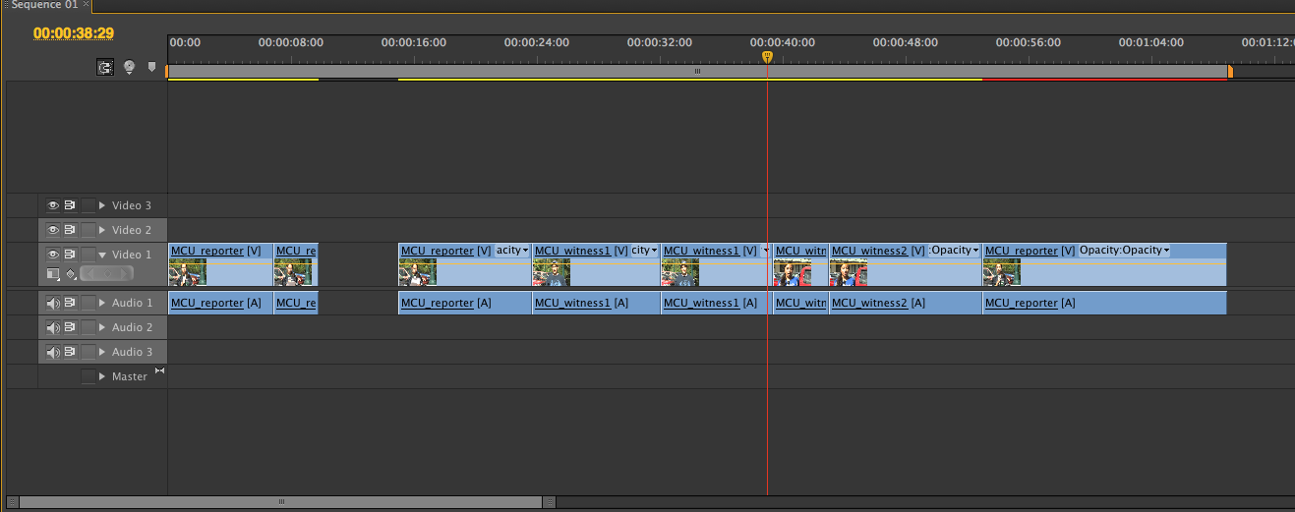

- “B Roll” – goes on V2,A2
**put appropriate video B-roll to match what is being said in the audio. Remember you need to edit out shaky camera or zooms before using it in timeline.
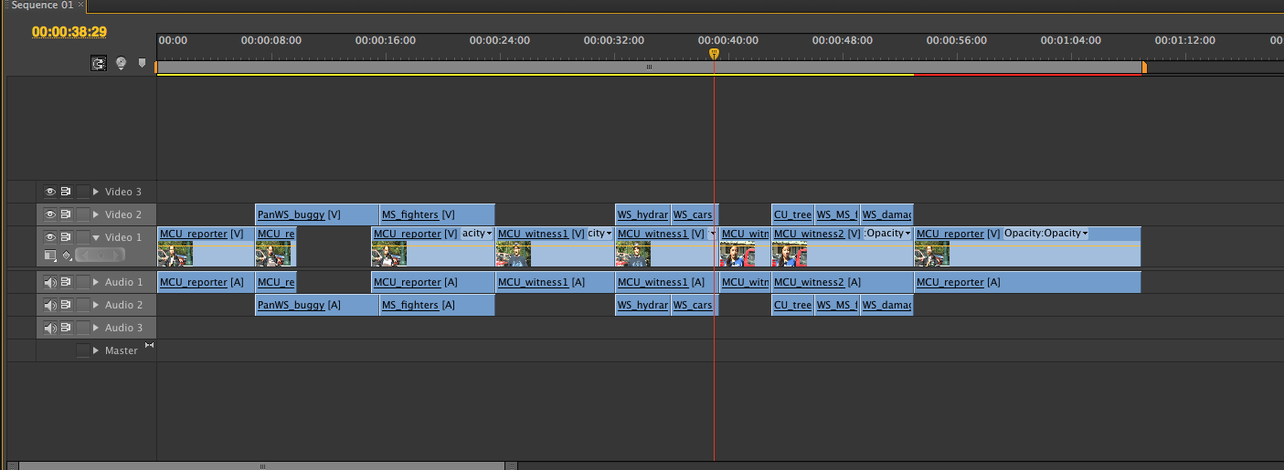

- LOWER THIRDS goes on V3
a. Go to Title ---- New Title ---- Based on Template
b. In the next window, look under Title Designer Presets for Lower Thirds
c. Scroll through the templates and choose one template to use for all 3 people
d. Type the names of the Reporter & Interviewees as on the script

- Audio - adjust audio levels so that the voices are higher and distinguishable over the natural sound.
- Expand audio layers by clicking on the triangle next to the word Audio
- Click on the individual audio clip on the track and look for the yellow line. Raise or lower the line to adjust the sound level so the voices are audible
- Add audio transitions (in the Effects tab on bottom left screen) and choose Constant Power and drop it at the start/end of the Broll sound to smooth it out.

- Slate - Fill out the slate and add it to the beginning of the timeline
Remember to use only the duration of the news story (NOT including the slate)
- Slate goes on V2

- Export Media – as a Quicktime, H.264 and call it the same name as the folder

