Naviance Student for Parents Reference Guide

Overview
Naviance Student makes it easier than ever for your student to answer the questions that will shape your student’s future: Who am I? What do I want to be? How will I get there? And How will I succeed?
Naviance Student is a mobile-responsive site, for both students and parents, that employs intuitive tools that personalize and simplify the college and career planning process.
Parents and/or Guardians have mostly view-only access. However, depending on your school’s permissions, you may be able to edit:
- Personal and Demographic Information
- E-Mail Address
- Username/Password
- Add a college to your child’s College’s I’m Thinking About list.

Logging In
Your school will have provided you either a:
- A Registration Code or
- A Username/Password
Navigate to our school’s Naviance Student page using the following URL:
{SCHOOLS MUST ENTER THEIR OWN NAVIANCE STUDENT URL; TYPICALLY, STUDENT.NAVIANCE.COM/SCHOOLALIAS}

Registration Code
- Your district should have sent you a registration code for use with Naviance Student.
- Navigate to your school’s URL.
- Click on I Need to Register.
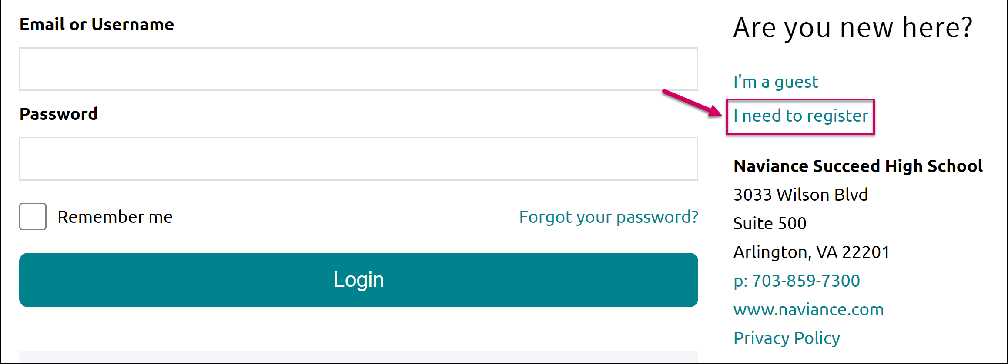
- Enter the registration code you were provided in the Registration Code field.
- Click Register.
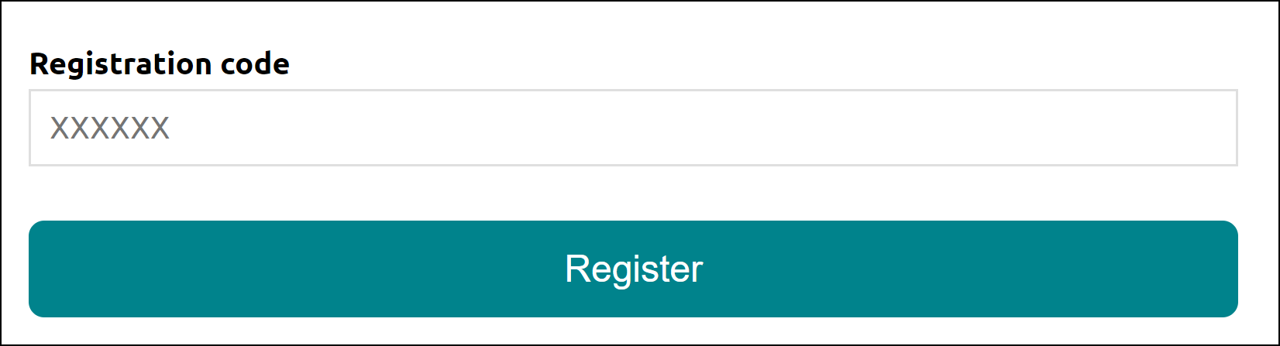
The Create Account page displays.
- Fill out the information as needed. If you have an e-mail address, select yes under the relevant question, and then enter your email and desired password. If you do not have an email address, you will be asked to create a username instead.
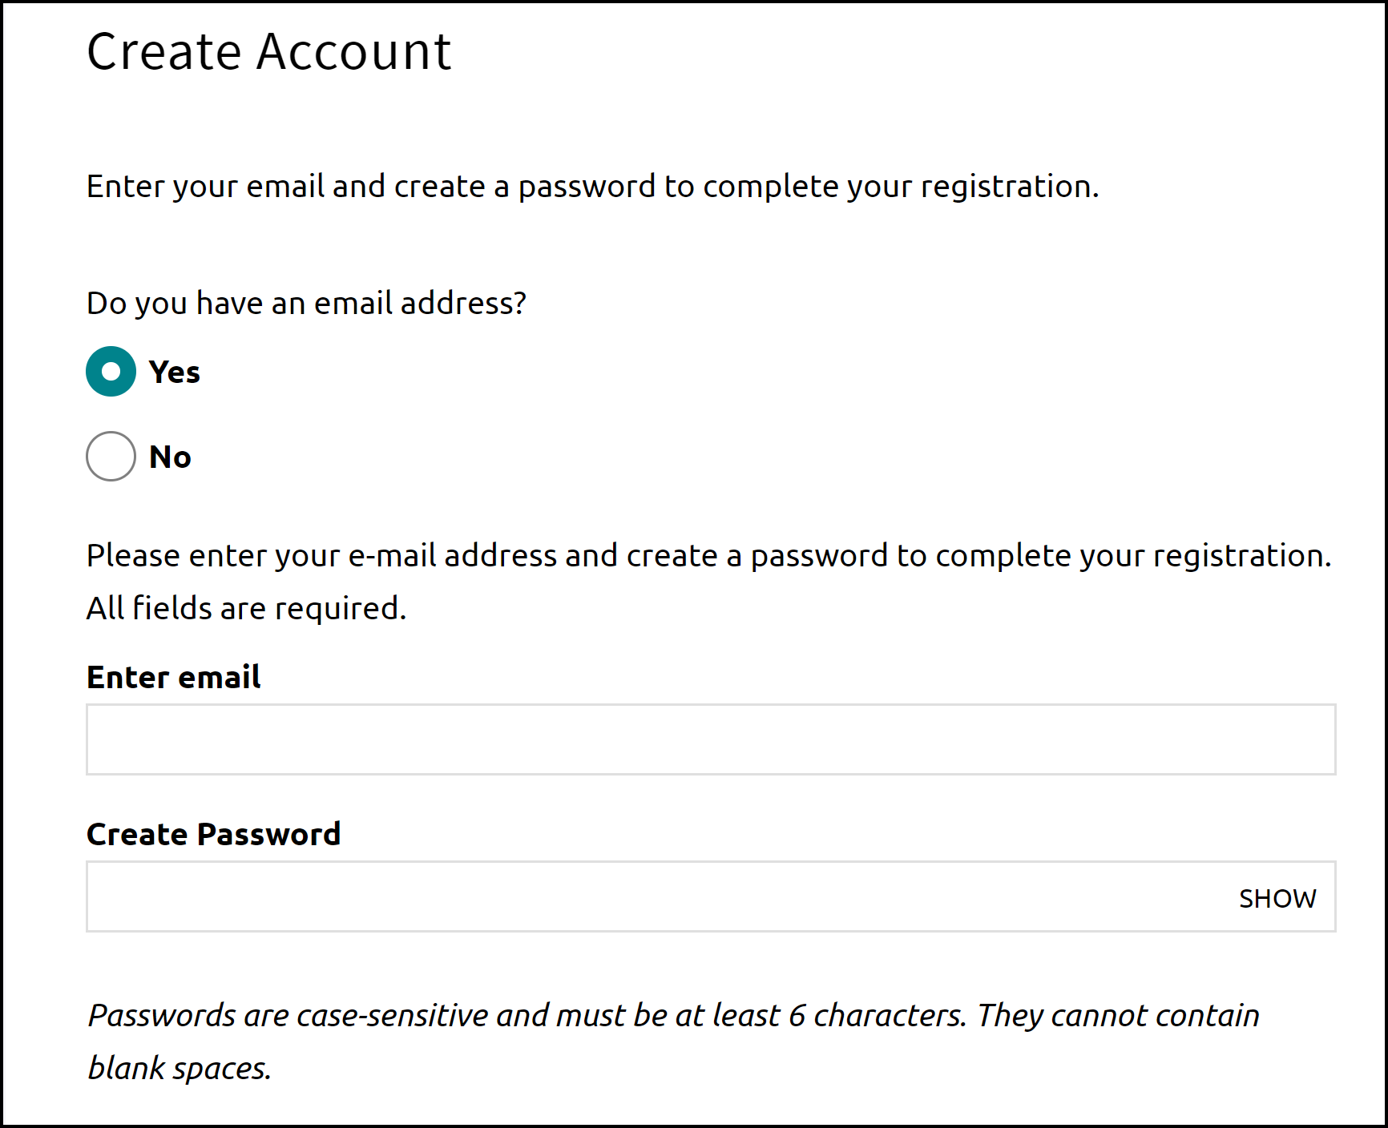
- Click Continue. You are now ready to log in.

Username/Password
If you were already provided or have created your username/password, go to the URL and use the fields to log in.

Navigating in Naviance Student
Once you are logged into Naviance Student, most of your experience will be view only. To learn more about navigating around and seeing what tools are available in Naviance Student, visit this video tutorial.
{SCHOOLS – USE EITHER THE DIRECT LINK TO THE NAVIANCE STUDENT OVERVIEW OR PROVIDE THE LINK TO THE WEBSITE TO WHICH YOU HAVE EMBEDDED THE VIDEO CODE}

Parent Tasks

Editing General and Security Information
You can edit your own personal and demographic information, as well as your user name and password in Naviance Student. To do this:
- Click the About Me menu drop-down and select My Account under your name. Do not select your child’s account.
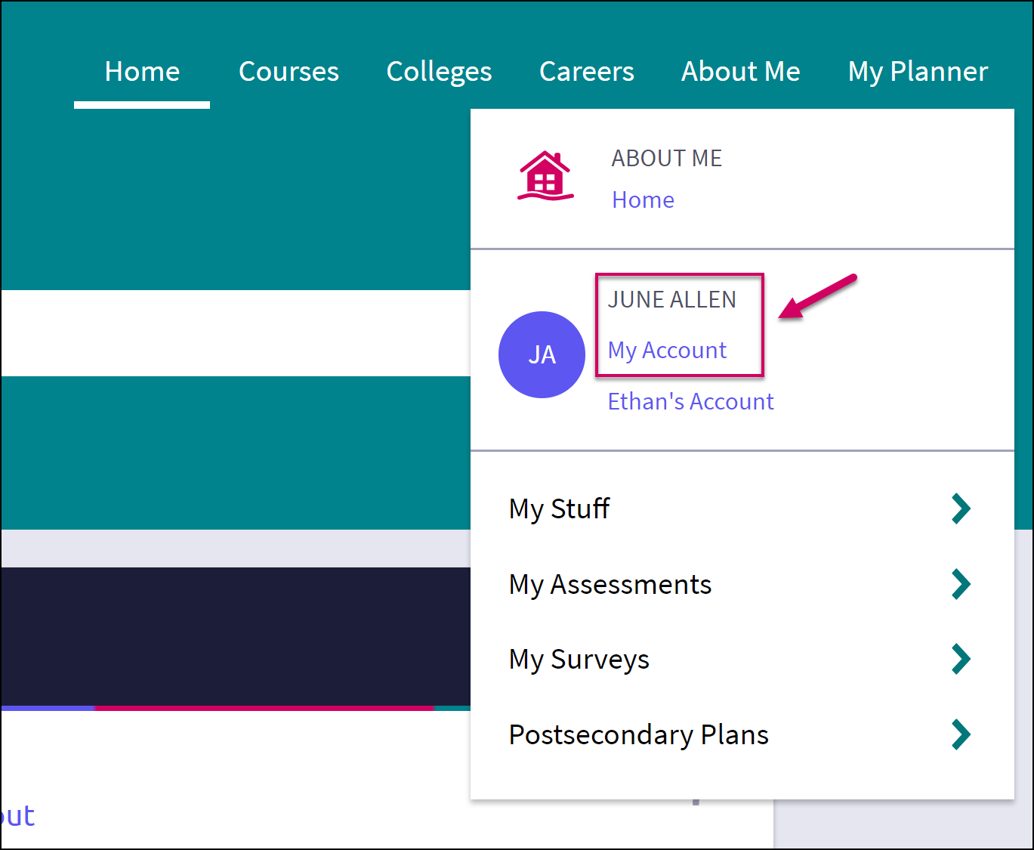
The account screen displays, and you are on the General Information tab by default.
- From General Information, click Edit to change personal information such as address, phone number, and email.
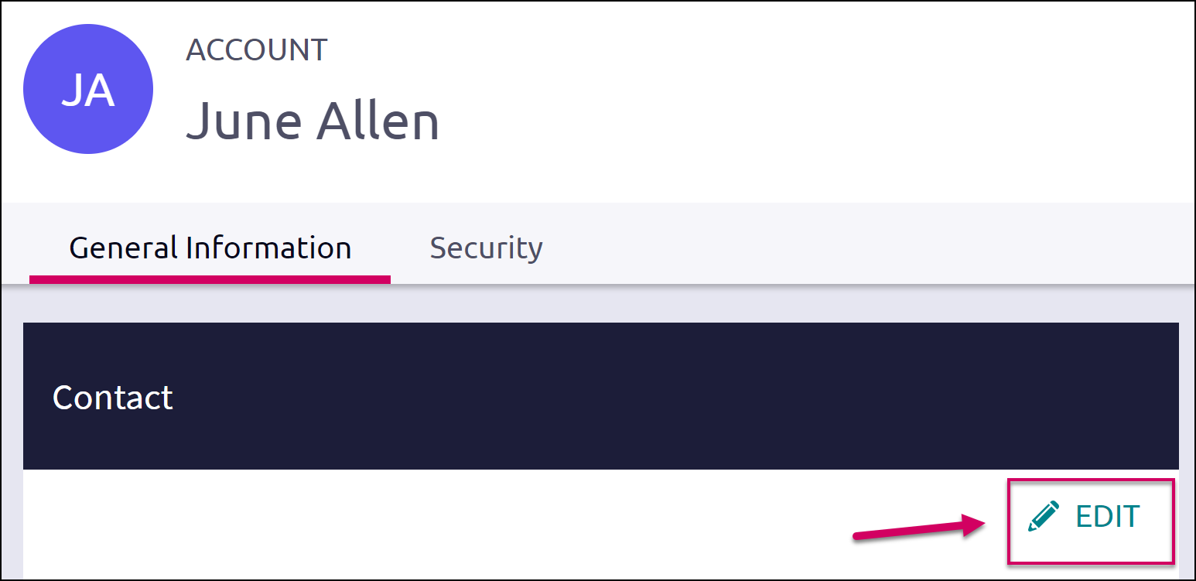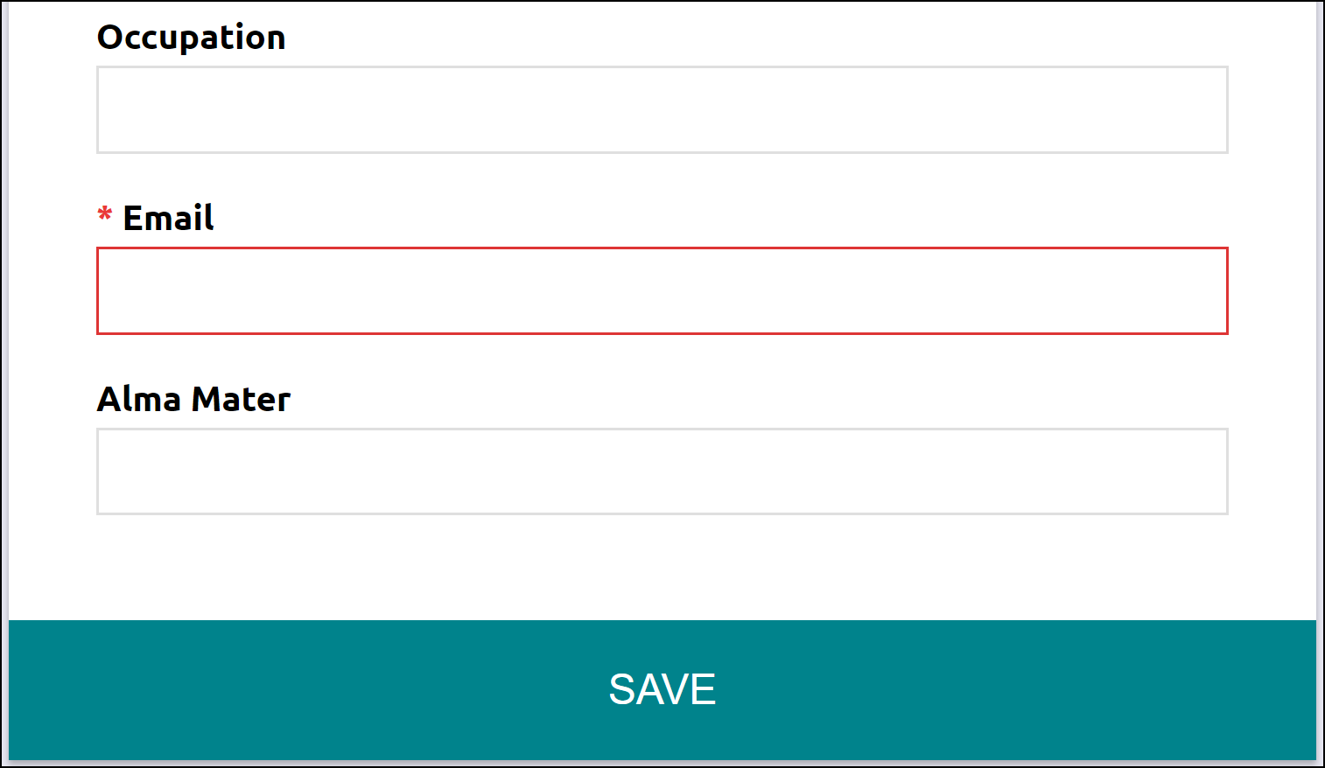
- Enter the new information and click Save.
- Click on the Security tab.
- Use Edit under either User Name or Password to make desired changed, and then Save.
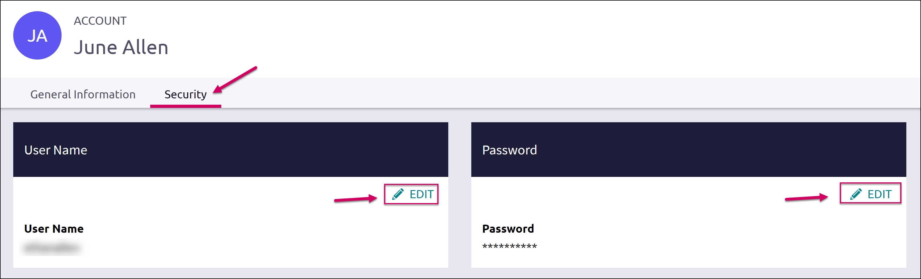

Adding a College to your Child’s Colleges I’m Thinking About List
Naviance Student provides a location for students to save the colleges they are most interested in. The Colleges I’m Thinking About List can be found right from the Home Page. As a parent, depending on rights your school has provided, you can add to this list for your child. To do this:
- From the Home page, use the Search for Colleges field to enter in the name of a school.
- Click Search.
The College Lookup displays with your search results. You can use this to further refine or change your search options.
- Check the box next to the school you would like to add to your student’s list.
- Click Save Selection.
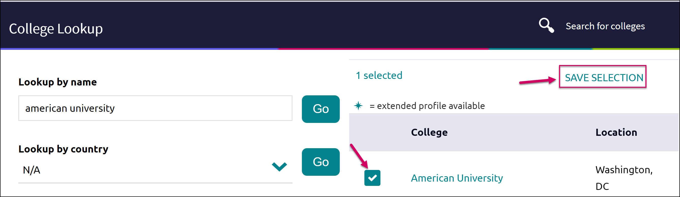
- Click Finished Searching.
The college is added to the list.
- To review the add, click the Colleges menu and select Colleges I’m Thinking About from the drop-down menu.
Your student’s list will display. You can see the item you have added by looking to the Added By column.
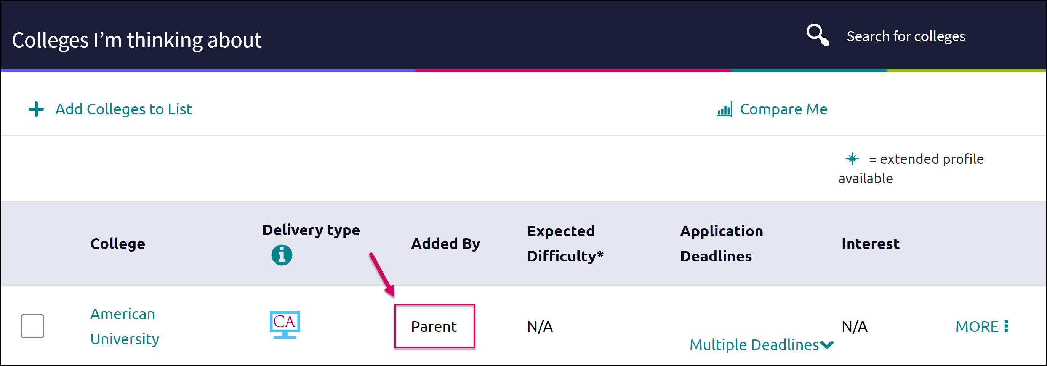

Switching Between Children
If you have more than one child in the district using Naviance Student, you can use the Switch Child drop-down to change the student account you are viewing.
