Virtual Microscope Worksheet

DIRECTIONS: Click on the link to the virtual microscope. Take the tour to learn how to use the microscope. When you are ready, practice using the letter “e.”
PROCEDURE (PRACTICE):
- Start with the blue 4x lens and find the letter “e.” If you did it correctly, you should see an image that looks like the image below.
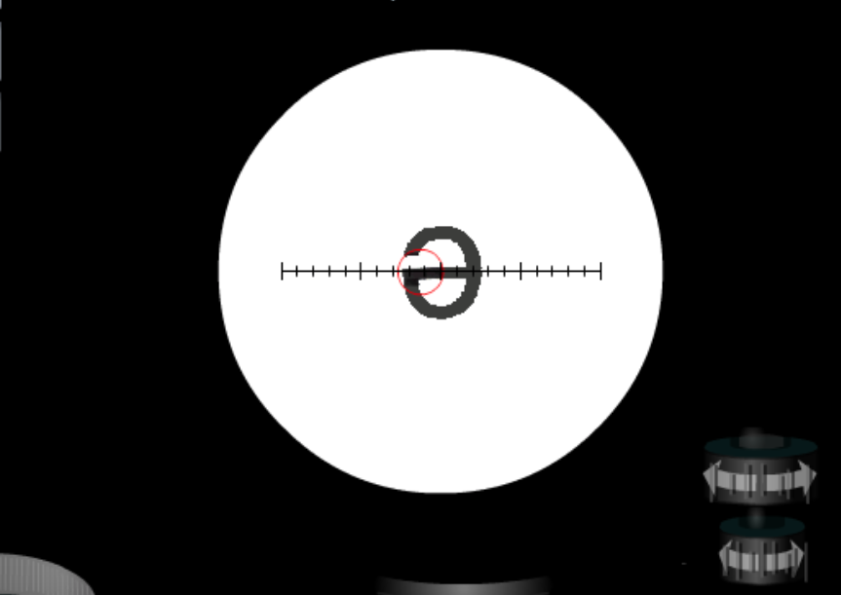

- Next move to the green 10x lens. If you did it correctly, you should see an image that looks like the image below.
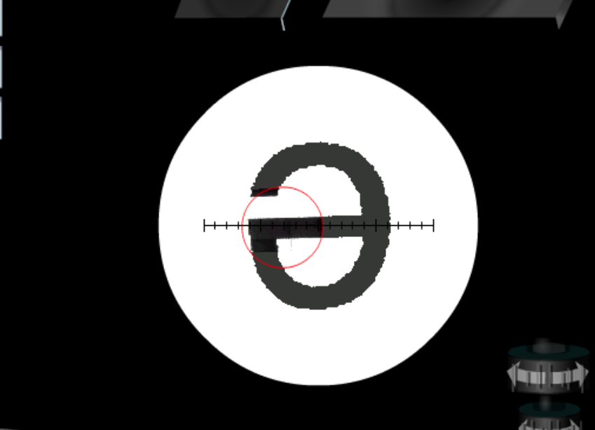

- Now move to the yellow 40x lens. If you did it correctly, you should see an image that looks like the image below.
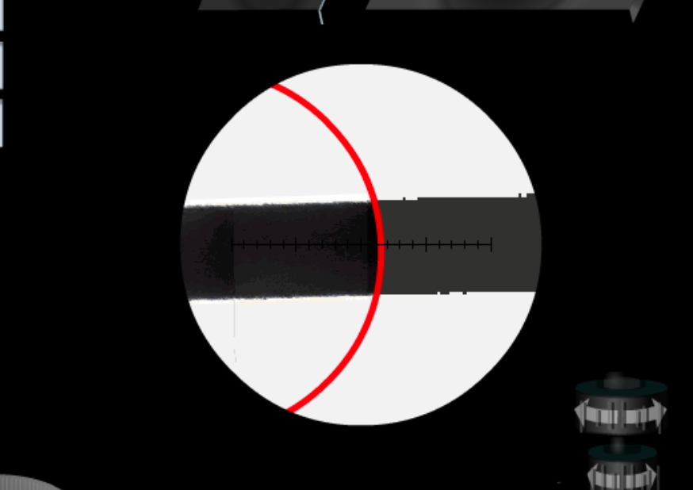

- Finally, move to the red 100x lens. If you did it correctly, you should see an image that looks like the image below.
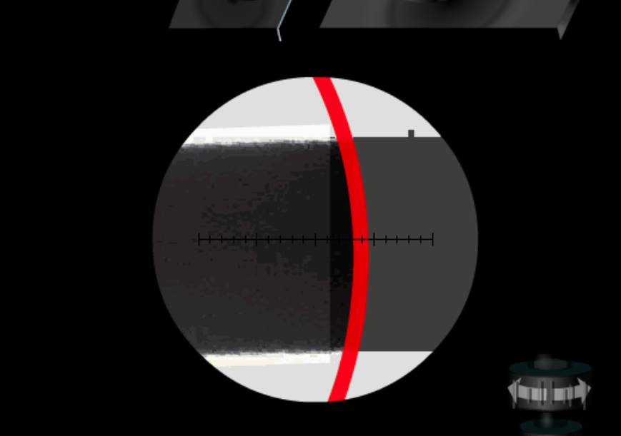

PROCEDURE (YOU DO IT)
DIRECTIONS: Choose ONE of the following slides: the onion root tip slide, bacterial capsule slide or the cheek smear slide. Place it on the stage and view it using the blue 4x lens, green 10x lens, yellow 40x lens and red 100 x lens. For each lens that you use, take a desktop picture (command, shift, 3) of the image you get. If you adjust everything correctly, you will see an image. You must be patient and never give up until you get clear image! Insert your pictures below in the appropriate space. Submit this document when you are done.

Name of Slide ____________________________
(name of the ONE slide you chose)

- Image with 4x lens
(insert your picture here)

- Image with 10x lens
(insert your picture here)

- Image with 40x lens
(insert your picture here)

- Image with 100x lens
(insert your picture here)

