VIRAL DISEASES

PART 2 – PRESENTATION SLIDES

After finishing your virus research, show your virus notes to Mr. Kaaa for his approval. Read the Presentation Rubric below so you know what you are being graded on. Next, in your google drive, create a new presentation. Name it like the sample below:
P8_kyle_kaaa_virus_present (P8 is Period 8)
Share your presentation with Mr. Kaaa and allow him to edit.
Choose a theme, then start on your slides. Here are the requirements for each slide:

Slide 1 (Title Slide) - Include a creative title, your first and last name and an appropriate image (picture) related to your virus.
Slide 2 (Virus Information 1)– Start your virus information (disease name, virus name, general information, etc. Include another image (picture) related to your virus.
Slide 3 (Virus Information 2) - Continue and end your virus information (transmission, symptoms, treatment, prevention).
Slide 4 (Graphic Organizer) – This is an OPTIONAL slide. Make a graphic organizer (Google Drawing) using any information related to your virus. Use shapes/symbols, arrows and key words. Also include a title. During your presentation, you will need to explain what your graphic organizer shows.
Slide 5 (Global and Personal Impact) – Show data/numbers about how this virus has impacted countries, nations and communities. Also comment on how learning about viruses has impacted you.

Additional IMPORTANT Information About Slides:
- Use subtitles to break up your information on slides.
- Do not use whole sentences on slides. Look at your notes/sentences and use KEY WORDS on slides.
- Use bullets before key words/information.
- All images NOT from the cdc site must be cited below the image in small letters (6 – 10 font size). SEE SAMPLE BELOW.

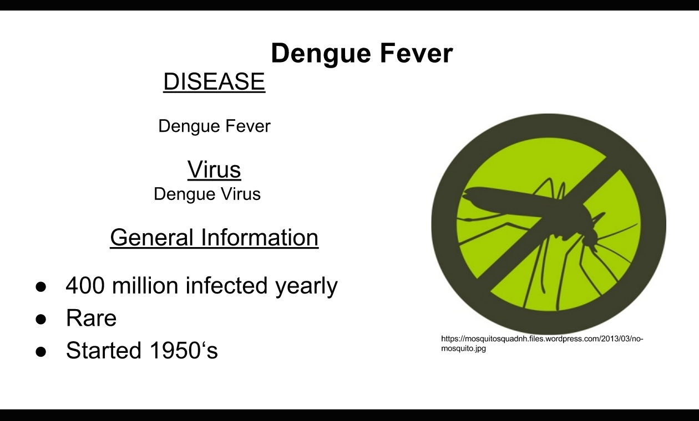

PRESENTATION RUBRIC

CATEGORY | 4  Exceeds | 3  Meets | 2 Progressing | 1  Beginning
SCIENCE CONTENT | Content is accurate and student demonstrates knowledge by explanations and elaboration and answers all class questions. (2x) | Content is accurate and student demonstrates knowledge by explanation and answers most class questions. (2x) | Content is questionable with some explanation and answers a few class questions. (2x) | Content is inaccurate, little explanation is given, no class questions answered.(2x)
SLIDE CREATION | Presentation reflects use of tools in a creative way. Correct number of slides. | Presentation reflects appropriate use of tools. Correct number of slides. | Presentation reflects some use of tools. Incorrect number of slides. | Presentation reflects no use of tools. Incorrect number of slides.
LAYOUT  (Pictures & Background) | Images enhance presentation. Layout of images and text is pleasing to the eye and clear. | Images are appropriate. Layout of images and text is pleasing to the eye and mostly clear. | Most images are appropriate. Layout of images and text is cluttered. | No images. Layout unorganized. Hard to read
MECHANICS | No spelling errors. Text is in authors’ own words. | Few spelling errors. Text is in authors’ own words. | Many spelling errors. Most text is in authors’ own words. | Many spelling errors. Text is copied.
VERBAL /  NONVERBAL  COMMUNICATION | Strong clear voice, precise pronunciation of terms, direct eye contact with audience, seldom looking at notes. | Clear voice, pronounces most words correctly, consistent use of direct eye contact but still returns to notes. | Voice is low, incorrectly pronounces words, some of audience has difficulty hearing presentation | Mumbles, incorrect pronunciation of terms, most of audience cannot hear presentation

