Secret Message Group B
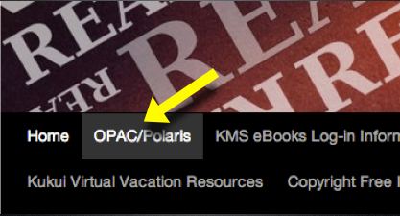
Directions: Read the questions carefully (some are a little tricky).
START HERE:
- Go to the KMS homepage blogs.ksbe.edu/kmslc
- Click on the “OPAC/POLARIS” link.

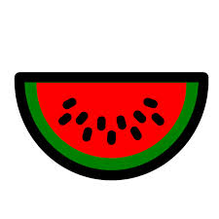 | Go to the library shelves and find the book Sites of Oahu by Elspeth Sterling. Turn to page 199. What ahupua’a is discussed in this section of the book?
 | What is the first word of the title of the book published by Veronica Roth in 2014?
 | The Power of ___ is part of a popular series written by Pittacus Lore.
 | n the book title, A Diamond in the Desert, Tetsu and his family are sent to this state after the bombing of Pearl Harbor.
 | Go to the library shelves and find the book Hawai’i Place Names by John Clark. Turn to page 249 and write down the first bolded location described on that page.
 | Go to the library shelves and find the book 47 Things You Can Do for the Environment. What word is printed on the post-it note on the front cover?
 | What number is mentioned in the title of the book edited by Andrea Woo?
 | Eric Herter is the author of the book Discovery: The Hawaiian ______.
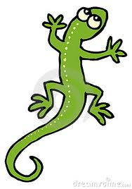 | According to the summary for the book, Mockingjay, how many times has Katniss Everdeen survived the Hunger Games?
 | Legends of Old Honolulu by W.D. Westervelt includes a legend about the bird-man of ________ Valley.
 | Find the title of the book written by Megan Crewe and fill in the missing word from the title. The Way We __________
 | Liz Gogerly is the author of the book A Teen Guide to ___Fashion.
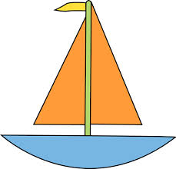 | One of the subjects of the book, When Children Play: The Story of Right to Play is ______________recreation—social aspects.

