Puʻulu Kukui Virtual Vacation State Research Project
Essential Question: How do people use geography in their everyday lives?

State: | Koʻu Inoa:

PLACE-Select at least 2 landforms/natural features to visit when you go sightseeing.  Select at least 2 historic sites to visit. Explain the significance of these historic sites. | NOTES | BIBLIOGRAPHY / CITATION (Resources used: websites, books, encyclopedia, etc)  *Google Online Research Tool: “Insert Link” AND “Cite”  *Easybib.com for books
At least 2 landforms/natural features to visit when you go sightseeing:  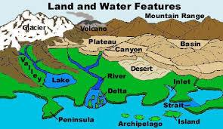 | Landform 1:  Landform 2:
At least 2 historic sites to visit. Explain the significance of these historic sites.  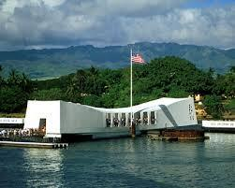 | Historic Site 1:  Historic Site 2:

REGION-  Describe the climate in the region you will be visiting. Keep in mind when you will be traveling so that your climate information is accurate. | NOTES | BIBLIOGRAPHY / CITATION (Resources used: websites, books, encyclopedia, etc) *Google Online Research Tool: “Insert Link” AND “Cite”  *Easybib.com for books
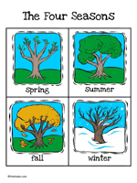 | Season of travel:
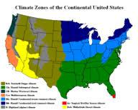 | Climate of region visiting:

MOVEMENT-  Research various airlines and select air transportation that is most affordable for your family. Identify the following: | NOTES | BIBLIOGRAPHY / CITATION (Resources used: websites, books, encyclopedia, etc) *Google Online Research Tool: “Insert Link” AND “Cite”  *Easybib.com for books
 | Airline Carrier (Ex: Hawaiian Airlines, Delta, United, American, etc):
Departure Flight Info:
Departure City: Honolulu
Departure Time (Hawaii-Time):

Arrival City:
Arrival Time (Vacation State-Time):
Return Flight Info:
Departure City:
Departure Time (Vacation State-Time):

Arrival City: Honolulu
Arrival Time (Hawaii-Time)
 | Roundtrip cost of airfare (per person): $

HUMAN-ENVIRONMENTAL INTERACTION-  Select at least 3 man-made attractions that you will be visiting during your vacation (e.g. amusement parks, shopping centers, sports stadiums, famous restaurants). Identify the following: | NOTES | BIBLIOGRAPHY / CITATION (Resources used: websites, books, encyclopedia, etc) *Google Online Research Tool: “Insert Link” AND “Cite”  *Easybib.com for books
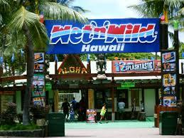 | Man-made attraction 1:  - Name: Wet ‘n’ Wild Hawaii  - Address (not longitude and latitude):  - Distance from your hotel (in miles):  Man-made attraction 2:  - Name:  - Address (not longitude and latitude):  - Distance from your hotel (in miles):  Man-made attraction 3:  - Name:  - Address (not longitude and latitude):  - Distance from your hotel (in miles):

LOCATION-  Research different hotels and find a hotel that is a reasonable distance from the airport and the sites you will visit. Identify the following: | NOTES | BIBLIOGRAPHY / CITATION (Resources used: websites, books, encyclopedia, etc) *Google Online Research Tool: “Insert Link” AND “Cite”  *Easybib.com for books
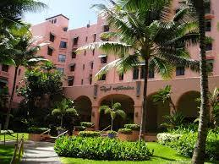 | Name of Hotel:
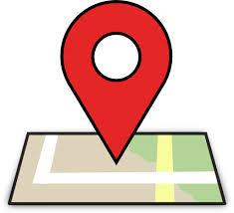 | Hotel Address (not longitude and latitude):
 | Total cost of lodging (assume that your family will stay in one room): $

TURNING ON GOOGLE RESEARCH TOOL:

1. Open your document in

2. Under the document name, find the |  | menu and select
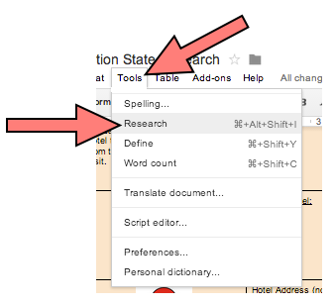

3. In the |  | type your |  | and press “Enter/Return” to get results from Google.
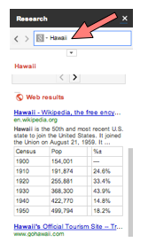
4. Scroll through your |  | Click on the |  | to preview the website to make sure it is a reputable and reliable source.

5. If you find a website with important information you need, place your cursor in the “Bibliography/Citation” column on the note taking sheet where that information belongs. Now click
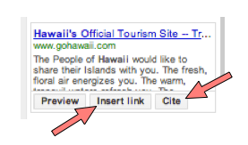

6. Now that website is cited and linked to your note taking sheet for research.

