Ha’ilono Introduction Note Taking Sheet
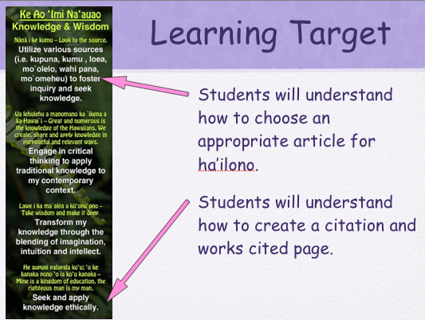

History of Newspaper in Hawai’i
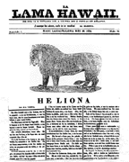
Ka Lama Hawai’i (The Hawaiian Luminary-inspiration)

- Lahainaluna on Maui

- Written in Hawaiian by students

Christian values, and geography
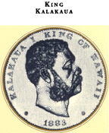

First newspaper by Native Hawaiians Ka Hoku o ka Pakipika (Star of the Pacific)

- Published by :J.K. Kaunamano

- Editor: David Kalākaua “the editor king”

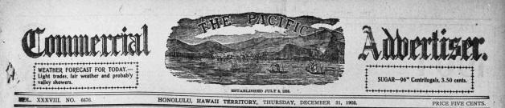

1st English language weekly paper

Daily paper

Name change to Honolulu Advertiser

- Honolulu Star-Bulletin:

- Honolulu Advertiser:

- Merge:

Parts of a Newspaper:

FRONT PAGE:

- General news

- National, international, and some local

LOCAL:

- Local news

- Obituaries

SPORTS:

- Sports

- Sports articles

TODAY:

- Entertainment

- TV schedule

- Crossword Searches

- Horoscopes

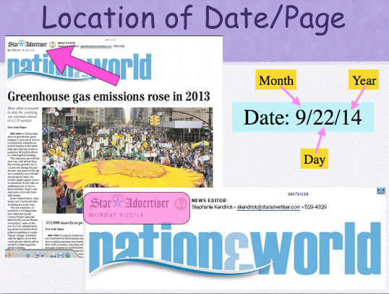

Brislin, Tom. Ka Lama Hawai'i. Digital image. University of Hawaiʻi Manoa. Web. 28 Sept. 2014. <http://www2.hawaii.edu/~tbrislin/images/kalama.gif>.
Brislin, Tom. Ka Lama Hawai'i. Digital image. University of Hawaiʻi Manoa. Web. 28 Sept. 2014. <http://www2.hawaii.edu/~tbrislin/images/king.gif>.
Brislin, Tom. Ka Lama Hawai'i. Digital image. University of Hawaiʻi Manoa. Web. 28 Sept. 2014. <http://hdnpblog.files.wordpress.com/2014/04/pcaheader.jpg?w=628&h=134>
Star Advertiser. Star Advertiser Logo. Digital image. Star Advertiser. Web. 28 Sept. 2014. <http://www.hawaiireporter.com/wp-content/uploads/2010/11/Picture-174.png>.

