7th Gr Polaris Notes
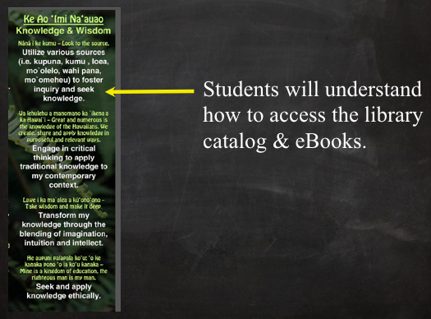
HOW TO FIND LC RESOURCES:

1. http://kapalama.ksbe.edu/middle. Select

2. Click on

3. Select the |  | you want to do in Polaris.

4. Click on

MORE DETAILS ABOUT THE BOOK
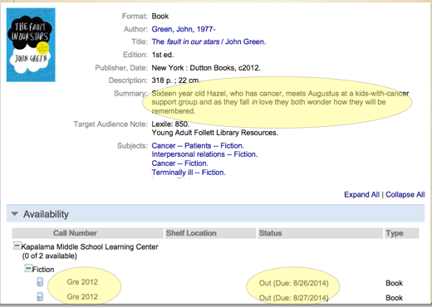
SEARCHING BY LEXILE

1. | Search: |  | for 720, |  | for 580, etc.

HOW DO I GET BOOKS FROM ANOTHER KS LIBRARY?

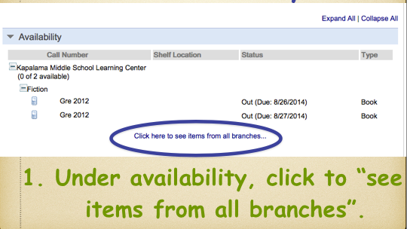 | 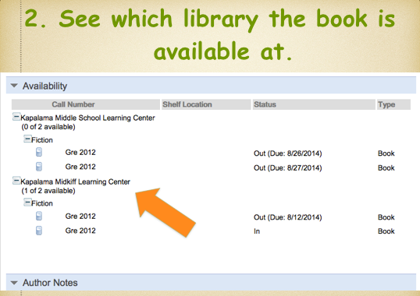 | 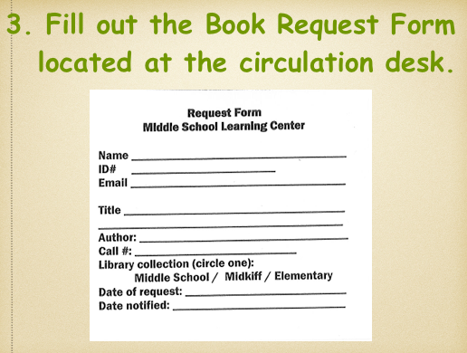

RENEWING YOUR BOOKS ONLINE

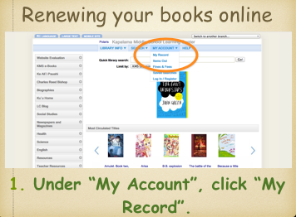 | 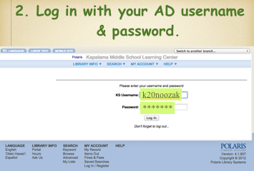 | 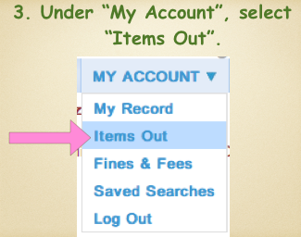
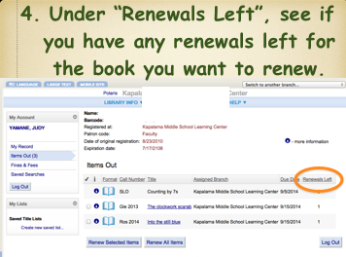 | 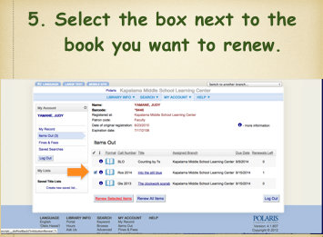 | 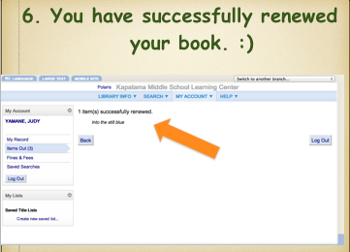

eBOOKS

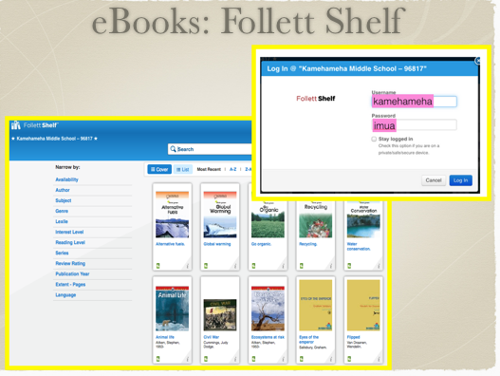 | 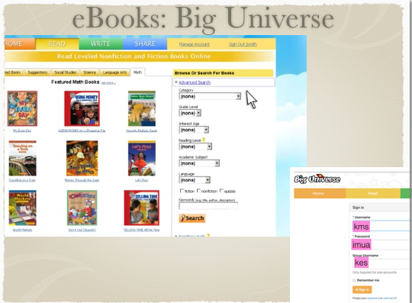 | 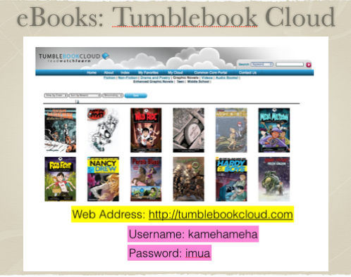
Username: kamehameha  Password: imua | Username: kms  Password: imua  Group Code: kes | Username: kamehameha  Password: imua

KMS LC EDMODO GROUP

