8th Grade Learning Center Orientation
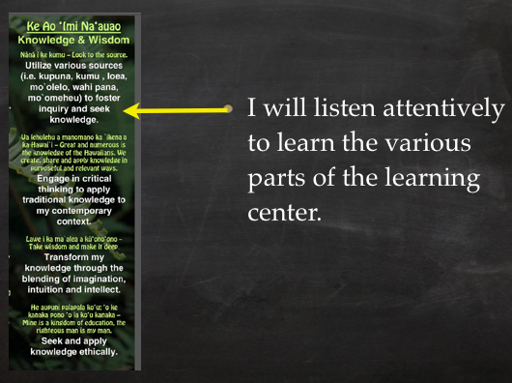

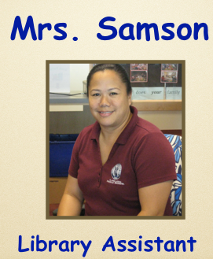 | 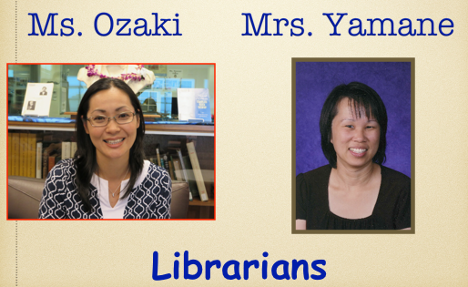

 | Favorite Color: | My Favorites: | Favorite Disney Movie:
Ms. Ozaki

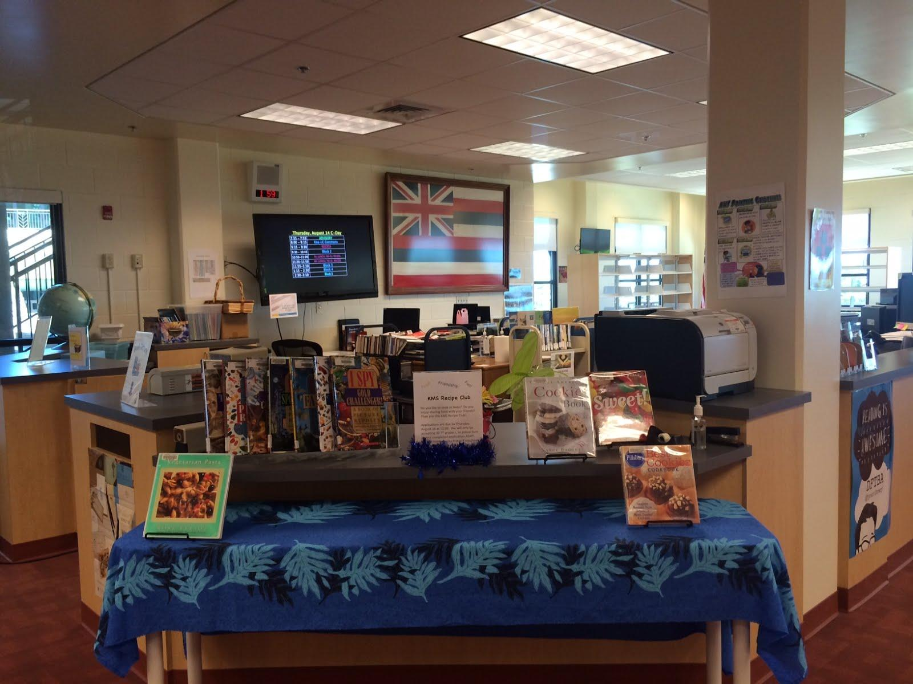
Learning Center Hours:
-need a pass

LIBRARY ETIQUETTE

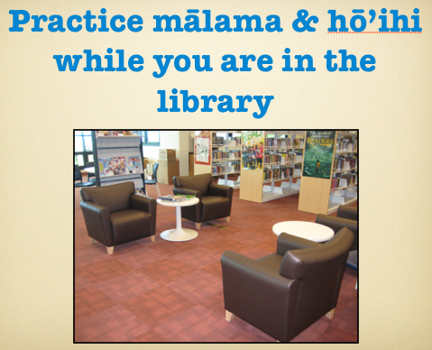

LOAN PERIODS/FINES
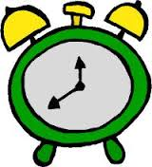
Borrow Books-
Fine-
Magazines-

Please |  | even if you |  | with you to pay for the fine.

- Check your email!
- Renew online

LOST OR DAMAGED BOOKS
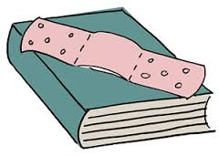

- Types of damage

- Replacement Costs*

- Paperback:
- Hardcover:
- Reference:

*Includes |  | $5 fee.

HOW TO FIND LC RESOURCES:

1. http://kapalama.ksbe.edu/middle. Select

2. Click on

3. Select the |  | you want to do in Polaris.

4. Click on

MORE DETAILS ABOUT THE BOOK
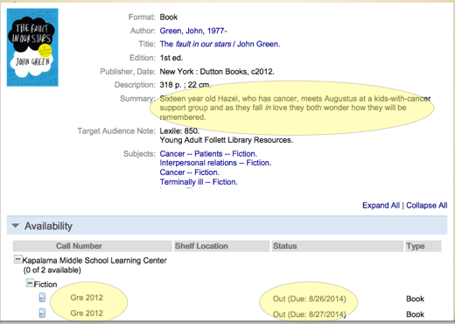
SEARCHING BY LEXILE

1. | Search: |  | for 720, |  | for 580, etc.

HOW DO I GET BOOKS FROM ANOTHER KS LIBRARY?

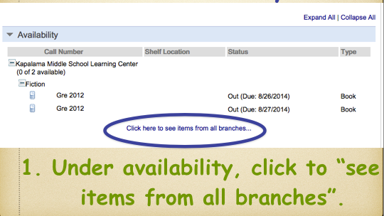 | 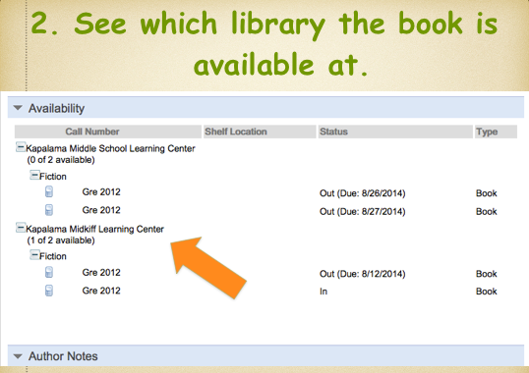 | 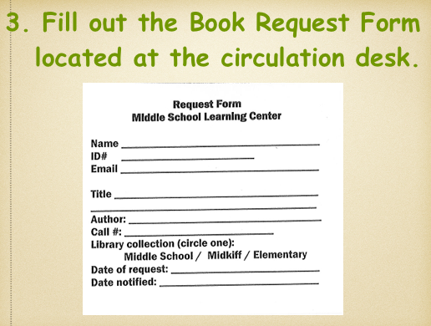

RENEWING YOUR BOOKS ONLINE

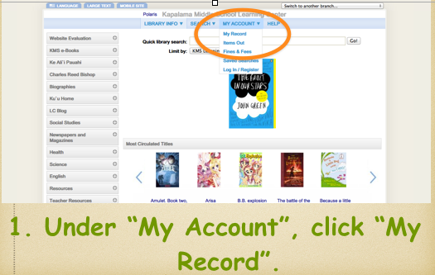 | 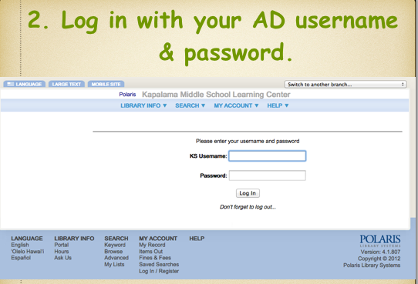 | 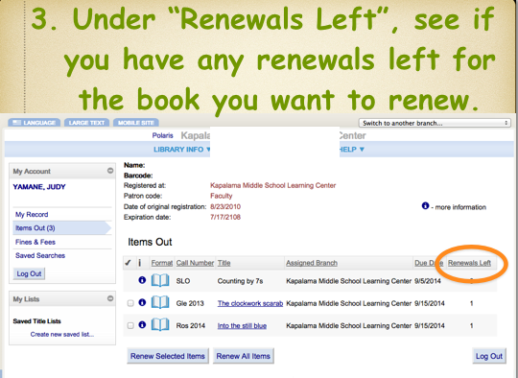

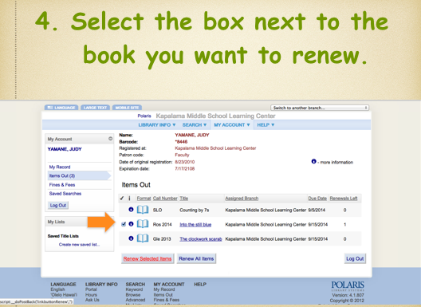 | 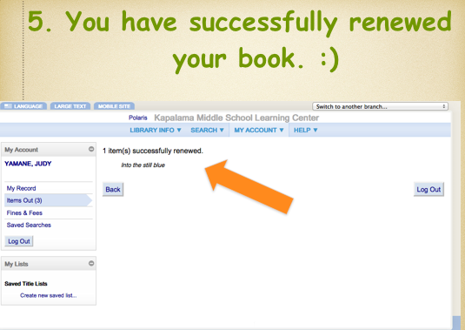

eBOOKS

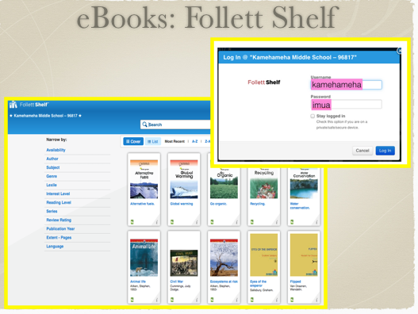 | 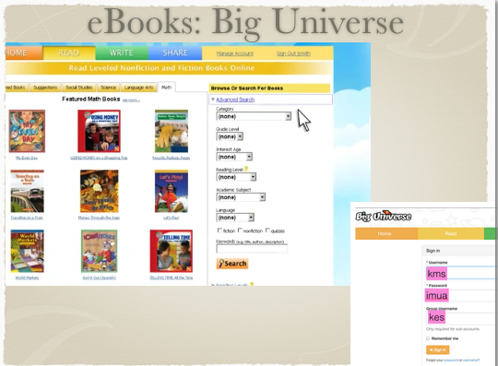 | 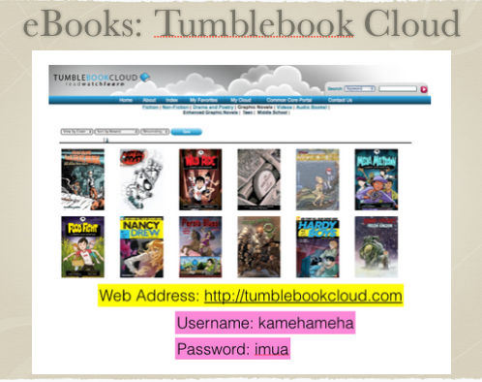
Username: kamehameha  Password: imua | Username: kms  Password: imua  Group Code: kes | Username: kamehameha  Password: imua

