7th Grade Learning Center Orientation
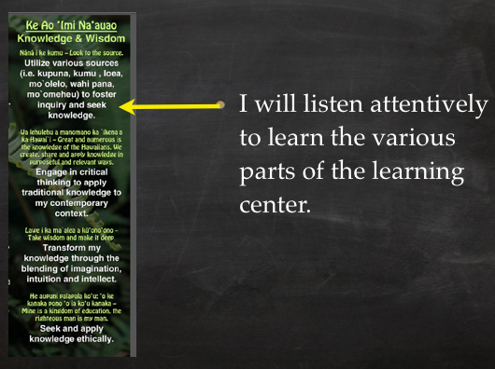
 | Favorite Color: | Hobbies: | Dog’s Name:
Mrs. Samson
Library Assistant

 | Favorite Color: | Hobbies: | Favorite Book:
Mrs. Yamane
Librarian

 | Favorite Color: | My Favorites: | Favorite Disney Movie:
Ms. Ozaki
Librarian

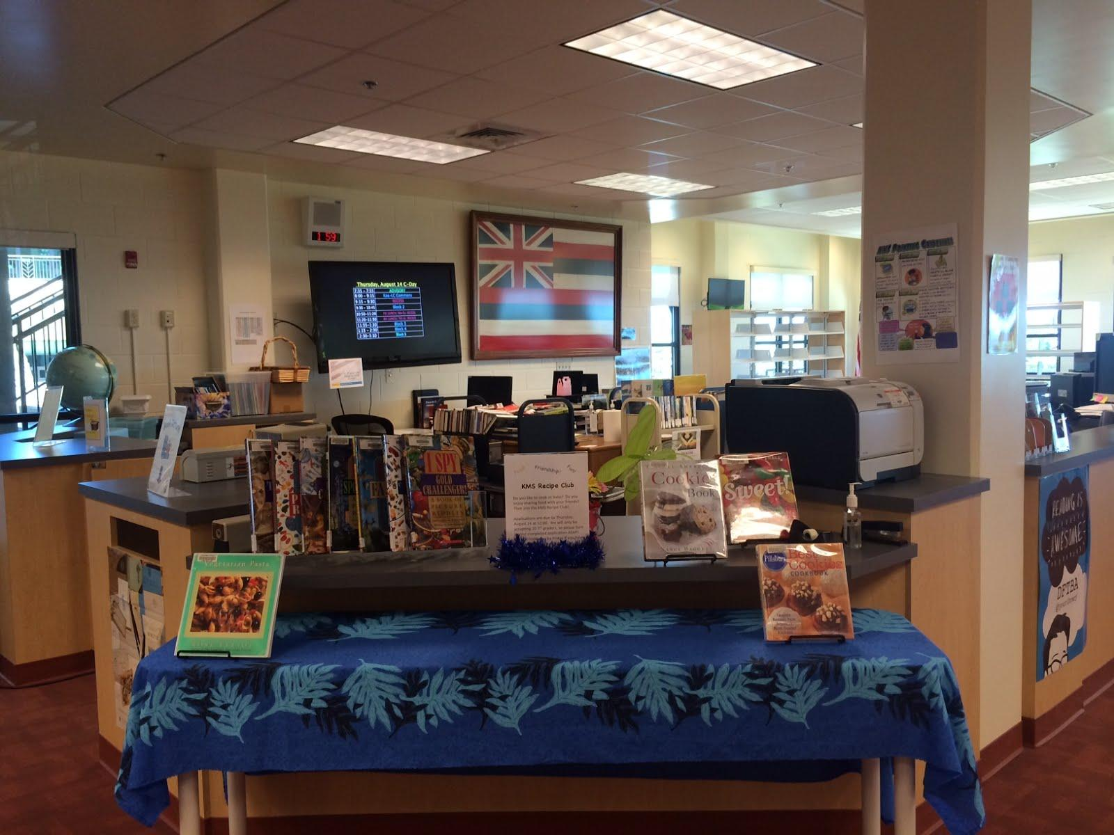
Learning Center Hours:
-need a pass

LIBRARY ETIQUETTE

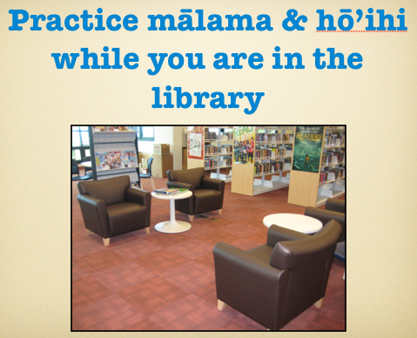
1. | chairs and |  | any that have been |  | from another table.

2. | chair per

3. You may sit on the floor if it is |  | and |  | the pathway of others.

4. When working in a |  | everyone needs to have their

5. | those who are reading by keeping the

6. Use |  | earbud.

7. Return books to

PROCEDURES
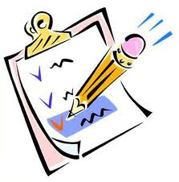
1. | (no water bottles)

2. | classroom until

BORROWING/RETURNING BOOKS
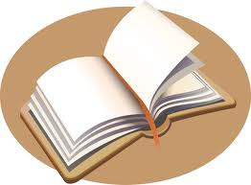
- Take |  | and |  | to circulation desk

- Bookmarks

- Book return

LOAN PERIODS/FINES
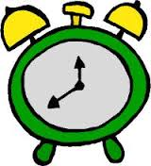
Borrow Books-
Fine-
Magazines-

Please |  | even if you |  | with you to pay for the fine.

- Check your email!
- Renew online

LOST OR DAMAGED BOOKS
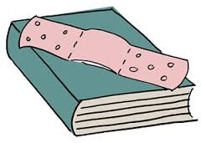

- Types of damage

- Replacement Costs*

- Paperback:
- Hardcover:
- Reference:

*Includes |  | $5 fee.

LIBRARY SERVICES

- Daily newspaper
- Magazines
- Desktop computers & scanners
- Copy machine

LIBRARY ACTIVITIES
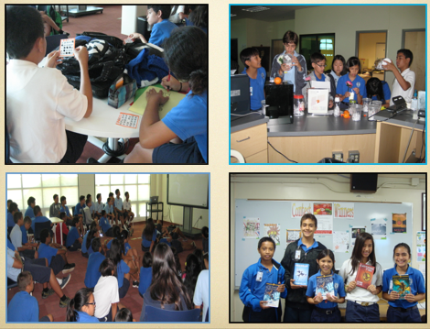

MAKERSPACE-LEGO
