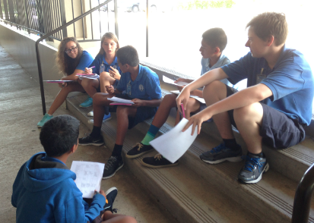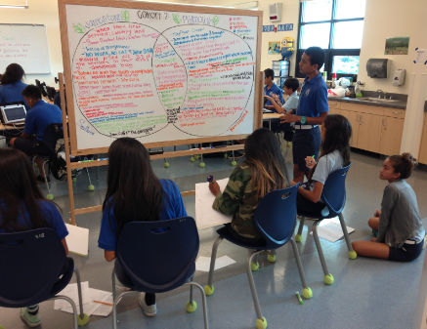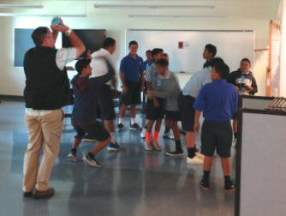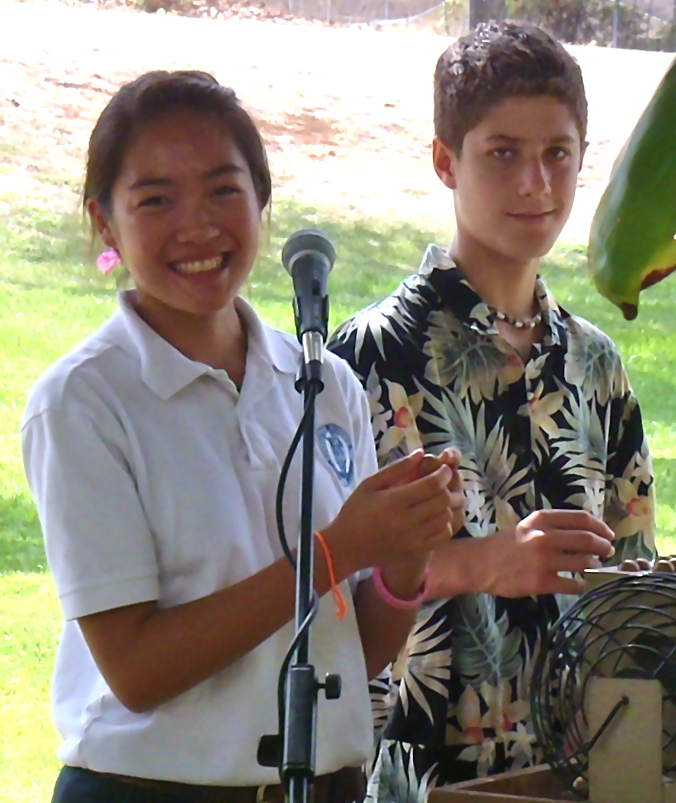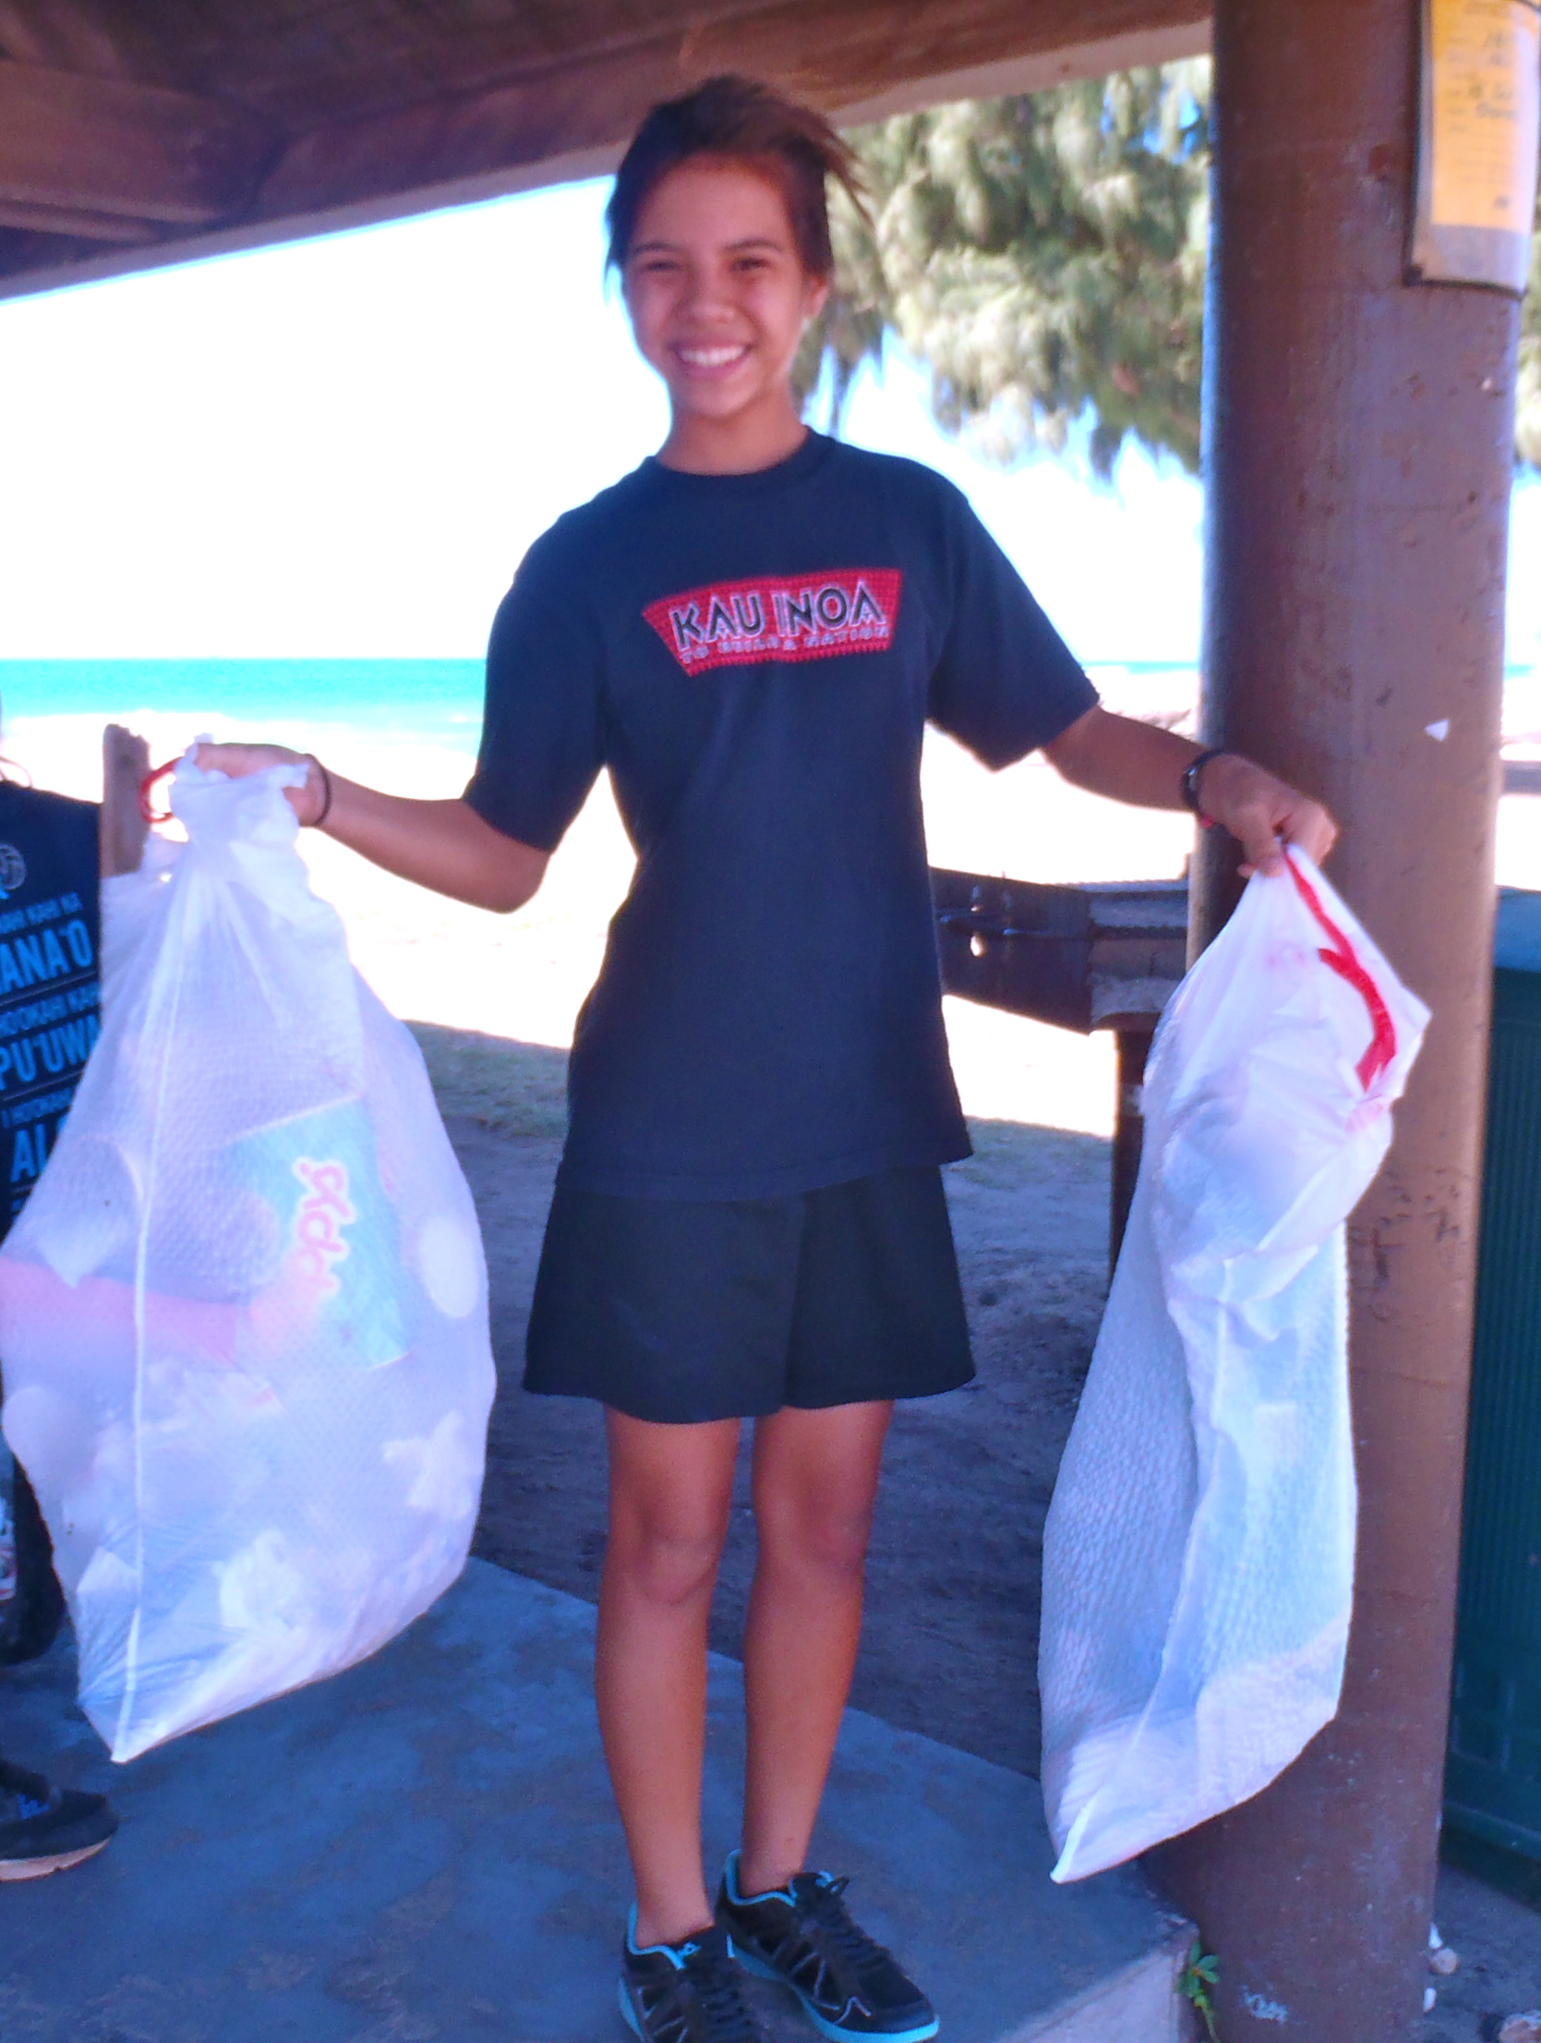

Be assured that our goal is to work with you to instill responsibility and ensure the success of your child this year. We look forward to having you actively participate in your child’s education.

**KAMEHAMEHA SCHOOLS KAPĀLAMA MIDDLE SCHOOL**

2125 Ali‘i Road  
Honolulu, HI 96817

**Pūʻulu**

**Lama**

We are delighted to welcome you to Pūʻulu Lama! We are anxious to launch the school year. With your support, your child will participate in and enjoy many exciting and rewarding experiences this academic year.

Since lifelong success depends in part on learning to make responsible choices, we have developed a behavior policy and student responsibilities list, which guides every student to make good decisions about his or her behavior and academic journey. Your child deserves the most positive educational climate possible for his/her growth, and we know that together we will make a difference in this process.

**Our Team Vision:**

**Pū‘ulu Lama**

***strives* for excellence,**

***nurtures* each other with**

**Christian and Hawaiian values, and *encourages* each other to be good citizens.**

## **E Komo Mai**

**Teacher/Parent/Family Responsibilities**

1. **Enjoy teaching AND learning.**
2. Guide all students to reach their potential.
3. Be a leader and mentor to our learners.

**You will need these supplies for all your classes on the first day of school:**

* ONE 1.5 in- 2 in. 3-ring binder
* Pencils
* Pens with blue or black ink
* Red pens for correction
* College-ruled folder paper minimum 250 count
* Correction tape
* Two Highlighters
* ONE 4 GB (minimum) jump drive
* One Ream of printer paper
* Earbuds (for use with laptops)
* ONE Facial tissue box (minimum 144 count)

**Student Responsibilities**

1. **Enjoy learning**.
2. Be courageous enough to fail at something.
3. Be willing to think “outside the box” to solve problems.
4. Take advantage of your opportunities at this school.
5. Practice ***Ke Ala Pono***, or “doing what is right”, at all times. Refer to the Kamehameha Middle School Student and Parent Handbook for further explanation.

**Student Handbook**

As returning students, eighth graders are familiar with the Kamehameha School Kapālama Middle School Student and Parent Handbook. However, we recommend you review this guide to the traditions, regulations, services, and activities of students of Kamehameha Schools. Particular attention should

be paid to the “General Guides and Procedures” and “Student Dress Codes” sections as they have been revised.

* Graph paper (100 sheets for the year)
* Four College ruled marble composition books
* One set of 12 Colored pencils and pens
* 3” X 5” Ruled Index Cards

**Pū‘ulu Lama Expectations**