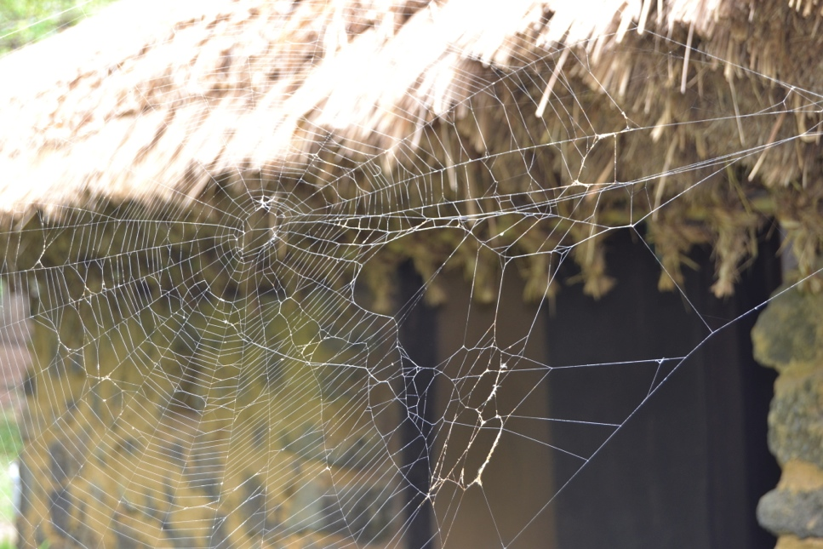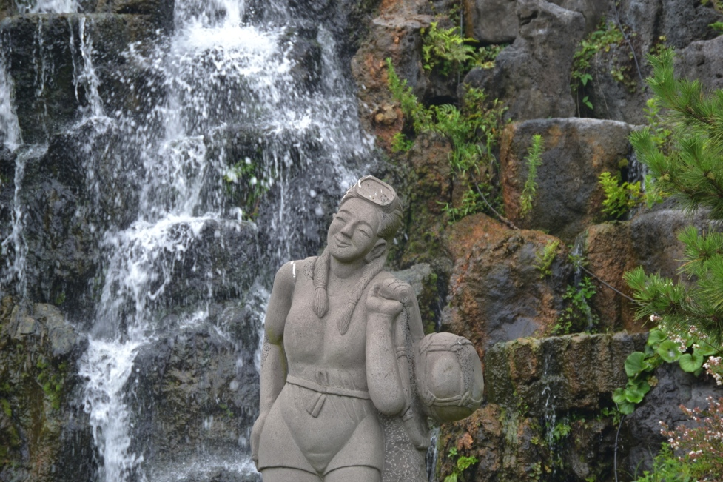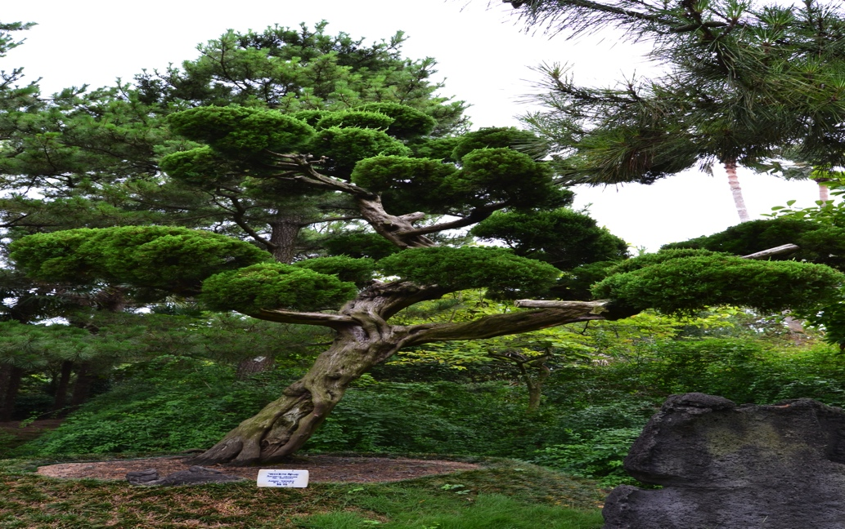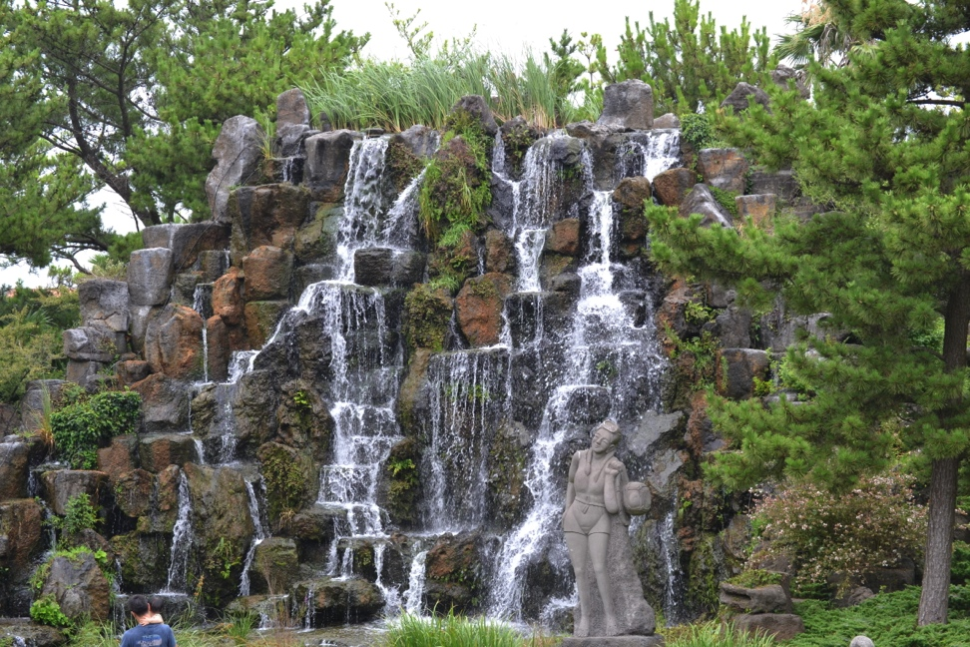

Come Visit

Our Trip!

Beautiful Views

Our Trip!

Put Stamp here

Put Stamp Here

Put Stamp Here

Put Stamp

here

# Dear Uncle Jeff,

# I am having such a great trip. Today we went to the waterfalls and also visited a zoo. The zoo had lots of animals and we ate ice cream.

# Tomorrow we are going to go swimming at the beach and try to find a cave. I will send you another postcard soon.

# Dear Mom,

# I am having such a great trip.

# Today we went to the waterfalls and also visited a zoo.

# Tomorrow we are going to the beach and trying to find a special cave. I will send you another postcard soon.

# From,

# Jamie

# Dear Maya ,

# I have been having lots of fun. It is a great trip . I can’t wait to tell you all about it when I get back.

# From,

# Jamie

# 

# Dear Mom and Dad,

# I am having such a great trip. Today we went to the waterfalls and also visited a zoo. The zoo had lots of animals and we ate ice cream.

# Tomorrow we are going to go swimming at the beach and try to find a cave. I will send you another postcard soon.

# From,

# Jamie