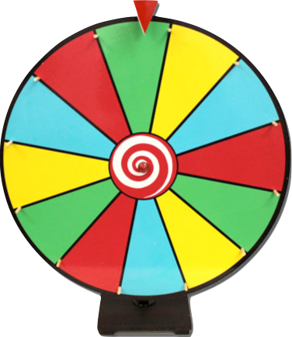

✹

want to spin the wheel?

Every time you write a 1-paragraph book review for us you will be entered into the monthly drawing. Each month one person will be selected to spin the wheel and try to win a prize. Grab a form below or complete one online at: http://goo.gl/Zkamf4

## REVIEW A BOOK

✹

# Doesn’t it look fun?