Pepeke ʻAike ʻO with ko/kā

Inoa:

Lä:

Hola Papa:
E hoʻomaʻamaʻa i ke ko/kā possessives ma lalo nei.

1. The huge ipu of Kumu Kimo 2. The cold chair of my dentist

Kumu Kimoʻs huge ipu My dentistʻs cold chair

3. The girl friend of the tall student 4. The fish of the shark

The tall studentʻs girl friend The sharkʻs fish

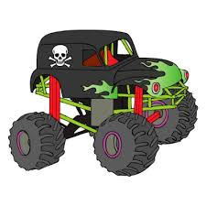
E koho i ke analula kūpono no kēlā māmala ʻōlelo kēia māmala ʻōlelo, e makaʻala i ka hoʻohana ʻana i ke “ko/kā” possession.

1. My momʻs friend is the Principal. 2. I saw your uncleʻs huge truck at McDonalds.

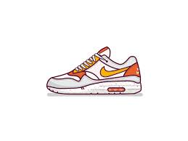

3. Hey Makana, your dadʻs catʻs food is old! 4. Lopakaʻs new shoes is on the table.

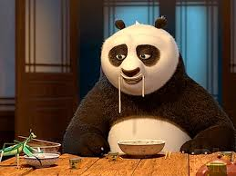

5. My cousinʻs friend plays Fortnite. 6. Thatʻs my dadʻs Chinese food.

