Pepeke ÿAike ÿO #1

Inoa: ____________________________

Lä: ________________________

Hola Papa: ________
ʻO wai kēia kanaka/mea?

E nānā ʻoe i nā kiʻi ma lalo nei, e pane ʻoe me ka hopuna ʻōlelo kūpono no ka wehewehe ʻana mai i ke kiʻi.

1. ʻO wai ʻo Maui? 2. ʻO wai ʻo Kim Possible?
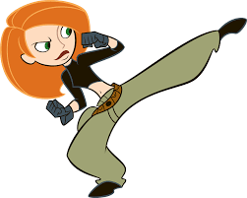
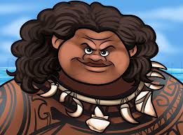

_______________________________________ _______________________________________

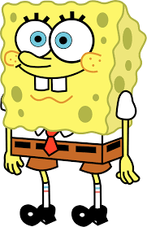
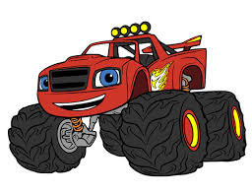
3. ʻO wai ʻo Sponge Bob? 4. ʻO wai ʻo Blaze?

_______________________________________ _______________________________________

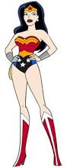
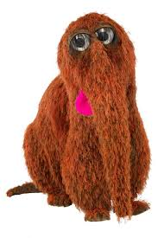
5. ʻO wai ʻo Wonder woman? 6. ʻO wai ʻo Mr. Snuffleugagus?

_______________________________________ _______________________________________

7. ʻO wai ʻo Bumble Bee? 8. ʻO wai ʻo Dori?
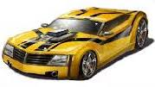
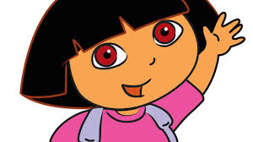

_______________________________________ _______________________________________

9. ʻO wai ʻo Black Panther? ʻO wai ʻo Scooby Doo?


 

