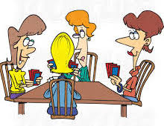
E pāʻani pepa kākou!!
Pāhana Pepa Pāʻani

In this pāhana you will be making a card game to enhance your Hawaiian language skills in hua helu (numbers) and waihoʻoluʻu (colors). Technology will also be integrated and play a huge part in designing your cards. All cards will be made on your computer in the application of your choice. Be creative, use pictures from the public in the Hawaiian language library of pictures we designed from the book project. You have the choice of creating one of the two games: ʻUNO or Hoʻomaopopo (Concentration). Each mea pāʻani targets your ʻōlelo Hawaiʻi skills in spelling, speaking and word recognition. Below are the expectations for each mea pāʻani.

ʻUNO
While working with a partner, each person will make one deck of cards. One person will choose 5 colors from the list of 10 (from our vocabulary list Nā Waihoʻoluʻu) to create a deck. The other partner will also make a deck but cannot choose the same colors as his/her partner. Use the ʻUNO deck as an example and feel free to revert to game to examine how many wild cards, reverse and skip your turn cards you will need for your deck.
- Each person will need 54 cards, a total of 108 cards.
- Each card will need a color design on one side of the card with a number indicating the type of card.
- Each card will need the word of the waihoʻoluʻu on the side with the color and number design.
- A design or word(s) on the opposite side of the card to indicate it belongs to a deck of cards.

HOʻOMAOPOPO (Concentration)
Ka Pāʻani (How to play the game): This is a game of memorization. The goal is to get as many packs of cards as possible. Each player takes a turn by turning two cards over. If the cards match, then the player picks up the cards and keeps them. If they don’t match, teh player turns the cards back over. If the player gets a match, they get to go again, until they fail to get a match. A match is when two cards have the same rank and color. The game is over when all cards have been matched and picked up. The winner of the game is the player with the most matches.
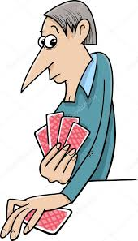

Expectations:
In the creation of this game you will be working by yourself. You will need a total of 40 cards for your deck. In our vocabulary list of waihoʻoluʻu there are 10 colors.

- 4 cards for each color with two different types of designs indicating they are a match. Example:

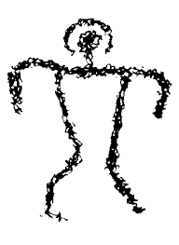
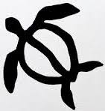

Uliuli
Uliuli
Uliuli
Uliuli

- Each card will need the word of the waihoʻoluʻu with with the color and design.
- On the opposite side of each card will need the words “E Hoʻomaopopo” indicating the name of the game and that it belongs to a deck of cards.

Grading Rubric
 | 9 – kō pono ke kuleana | 6 - ʻAno mākaukau | 3 – Pono e hoʻoikaika | 0 - ʻAʻole i kō
Hua ‘Ōlelo | Vocabulary present, all words spelled correctly and matches meaning | Vocabulary present, but mispelled words | Vocabulary present, but with incorrect meaning | No vocabulary present on cards
Amount of Cards | Appropriate amount of cards as stated per mea pāʻani |  |  | Not enough cards as stated in expectations per mea pāʻani
Technology integration/ creativity | Technology is evident, more than one design is used on each card | One design on one side of the card | No technology evident, designs/colors were done by hand
Exceeds | Play with a family member and record person stating their learning of all vocabulary words (numbers or colors) | Play with a family member and record person stating their learning of at least 4 vocabulary words (numbers or colors) | Play with a family member and take a picture during your game
Total pts

