Inoa: _____________________

Lā: ___________________

Negating the He Pattern Hola papa: _________

- He koholā paha kēia? 2. He kīlape paha kēia?
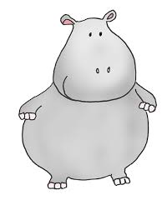

_______________________ _______________________

_______________________ _______________________

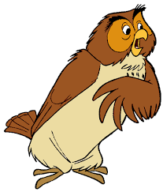
3. He palamiko paha kēia? 4. He lāpaki paha kēia?

_______________________ _______________________

_______________________ _______________________

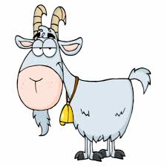
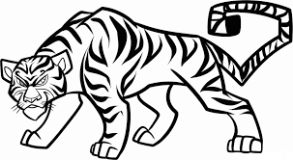
5. He liona paha kēia? 6. He ʻiole paha kēia?

_______________________ _______________________

_______________________ _______________________
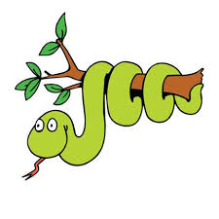
7. He hipa paha kēia? 8. He pueo paha kēia?
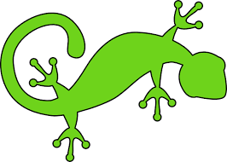

_______________________ _______________________

_______________________ _______________________

9. He laehaokela paha kēia? 10. He kao paha kēia?
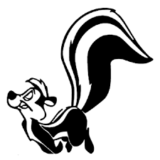
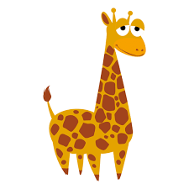

_______________________ _______________________

_______________________ _______________________

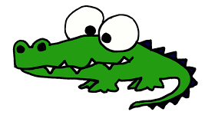
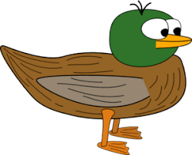
11. He ʻio paha kēia? 12. He puaʻa paha kēia?

_______________________ _______________________

_______________________ _______________________

