Haʻawina #2 Inoa: _________________________

Lā: ___________________

Negating the He Pattern Hola papa: _________

Negate the following sentences below according to the picture, becareful of the type of subject (kēlā, kēia, ʻo ia) in the sentence. All negating sentences must have a kāhulu. Note: some kāhulu will need to be modified according the picture.

- He keiki liʻiliʻi paha ʻo ia? 2. He kaʻa pupū paha kēlā?

_______________________ _______________________

_______________________ _______________________

3. He haumāna akamai paha ʻo ia? 4. He kalaka liʻiliʻi paha ʻo ia?
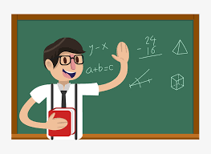

_______________________ _______________________

_______________________ _______________________

5. He ʻāpala momona paha kēia? 6. He kāmaʻa liʻiliʻi paha kelā?
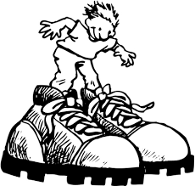

_______________________ _______________________

_______________________ _______________________

7. He kanaka lōʻihi paha ʻo ia ma ka hema? 8. He kāne hauʻoli paha ʻo ia?
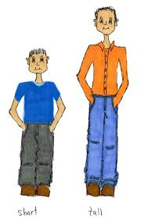

_______________________ _______________________

_______________________ _______________________

9. He pale ʻili nani paha kēia? 10. He puke kahiko paha kēiā?

_______________________ _______________________

_______________________ _______________________

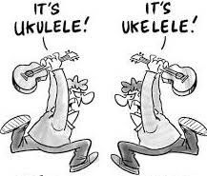
11. He wahine hula Hawaiʻi paha ʻo ia? 12. He pila kū nui paha kēiā?

_______________________ _______________________

_______________________ _______________________

