Pepeke `Aike He – Practice 4

Inoa: _________________________________

Lä: __________________

Hola Papa: _______

Write a pepeke `aike he to describe each picture. All sentences must have an ʻAWE and a kähulu examp: He kaʻa ‘ākala kēia ma ke alanui.

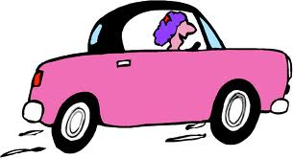

1. 2.

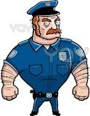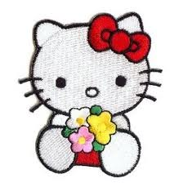

3. 4.

5. 6.

7. 8.
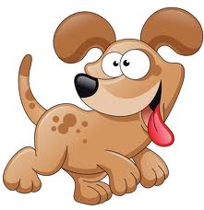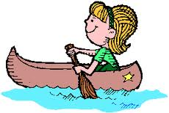

9. 10.

