Pepeke Painu Action

Inoa:________________________________________Lä:______________

Find out from your fellow classmates who likes to do the particular hobbie or action in the pictures below, then create a Pepeke Painu Action sentence accordingly for each picture. Each sentence must have a Po’o, Piko and ‘Awe. Note: on the backside of this haʻawina is vocabulary to help you translate your sentences.

1. 2.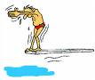

________________________________ ______________________________

3.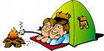 4.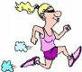

_________________________________ ______________________________

5.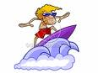 6.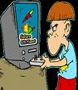

_________________________________ ______________________________

7.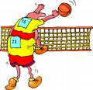 8.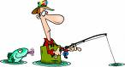

___________________________________ ______________________________

9. 10.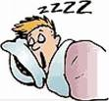

____________________________________ ______________________________

Hua ‘ōlelo Hou:
‘Olelo Pelekania | ‘Olelo Hawai‘i
Plays | Pā‘ani
Football | Pōpeku
Dives | Lu‘u
Camps | Ho‘omoana
Surfs | He‘enalu
Video games | Wikiō
Volleyball | Pōpa‘ipa‘i
Fishes | Lawai‘a

