Pre-Calculus with Trigonometry
1.0 credit / class meets on A or B days for entire 2017-2018 school year

Instructor: Ms. Kathleen Frampton Classroom: Y-209 Kalanikūpule
Email: kaframpt@ksbe.edu Phone: 808-573-7275
Blog: blogs.ksbe.edu/kaframpt/
Office Hours: after school, by appointment

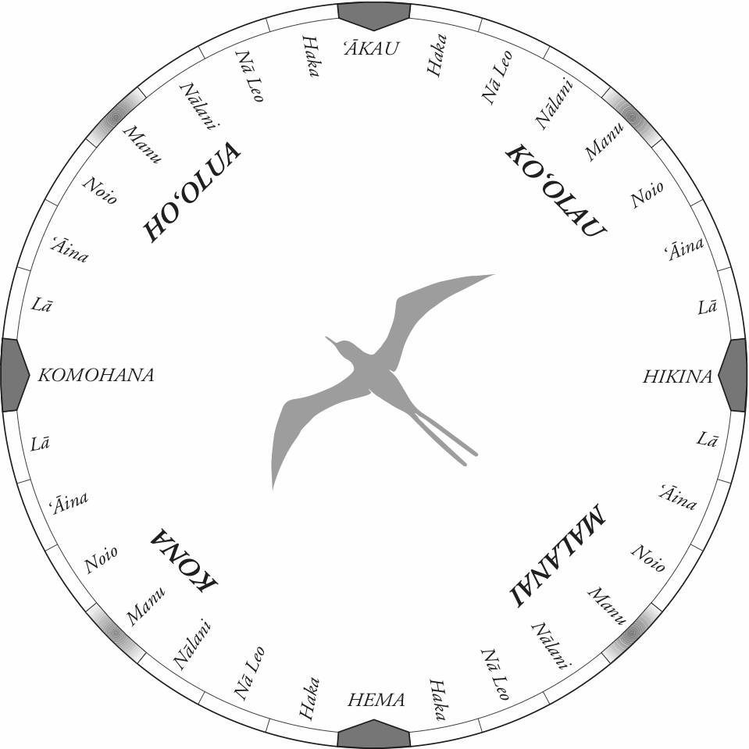
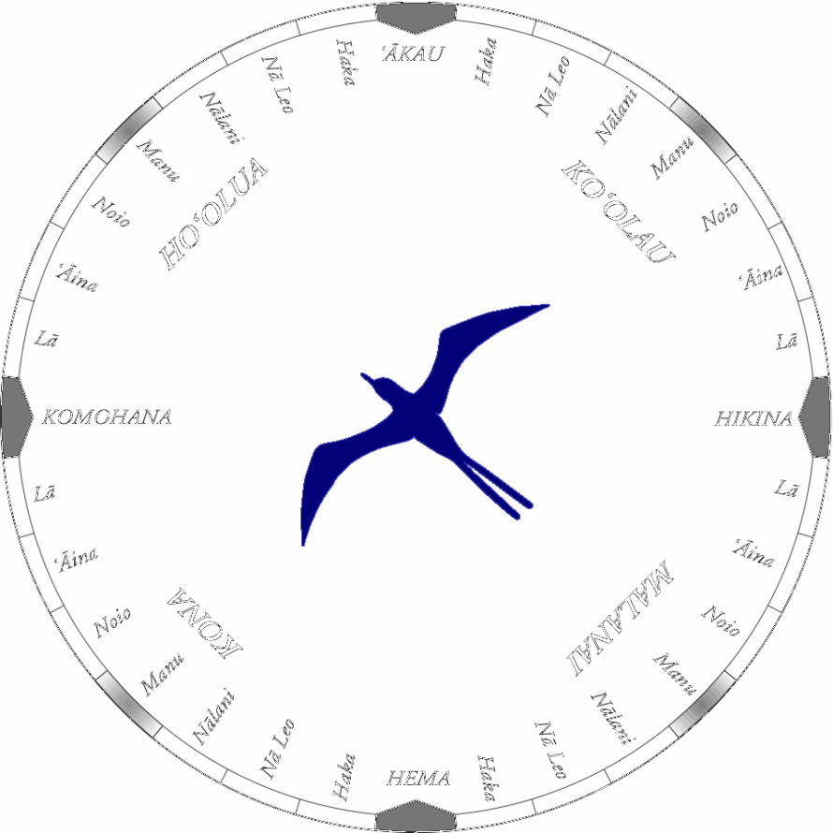
Prerequisite: completion of Algebra 2 with C- or better

Course focus and description:

This course strengthens algebra skills & investigates such topics as
data analysis, probability, vectors, matrices, polynomial, elementary &
trigonometric equations, through both traditional & application based methods. With such experiences, our vision is to have haumāna who will be able to appropriately use mathematical models & tools to reason & evaluate with precision as well as construct & justify viable arguments in global situations. This class is highly recommended if pursuing a field in business or science.

Student Learning Outcomes:

By the end of this school year, students should be able to:
illustrate & identify a variety of angles in degree & radian measure; | create appropriate functions from realistic scenarios;
recognize & know the characteristics of the 6 periodic functions; | recognize, manipulate & transform various polynomial & elementary functions algebraically & graphically;
distinguish between the 6 trigonometric ratios & do such computations within triangles; | find probabilities, expected values, permutations & combinations of events;
formulate variations of & do computations with trigonometric identities & composite argument properties; | illustrate, compute & interpret vectors;
derive & use general triangular formulas; | do matrix calculations.

Major texts, literature, or resources required daily:

Precalculus with Trigonometry textbook – provided ($85); textbook # ________
TI graphing calculator – provided if needed ($117); calculator # ________
lined & graph paper, composition book;
pencils, pens, markers, erasers;
correction tape;
protractor, ruler;
laptop – provided
3-ring folder, dividers. Attitude affects aptitude!

General course outline:

August: angles & the trigonometric functions
September: circular functions
October: trigonometric identities
November: composite argument properties
December: general triangular formulas
January: linear, quadratic, exponential, power & rational functions
February: logarithmic & logistic functions
March: probability, permutations & combinations
April: vector computation
May: matrices

Grading each Quarter:

Type of work | Weight on grade
Classwork: activities; journals; presentation of math exercises; worksheets;  participation; etc. | 25%
Homework: bookwork; handouts; blogs; etc. Assigned daily; due next class.  Late work accepted. Submit Revisions for higher score. | 25%
Assessment: projects; tests; quizzes; portfolios; etc.  No re-takes. | 50%

Full credit for on time, complete, correct, honest & neat work. Partial credit awarded.
Semester grade = 2 previous quarter percentages (40%, 40%) & semester exam (20%).

Homework Revisions – resubmit, for a perfect score

1st: On new paper, write a complete sentence stating your error, for each incorrect exercise.
2nd: Re-do each incorrect exercise entirely, showing your work.
3rd: Write another couple of complete sentences for each corrected exercise explaining your solution process.
4th: Staple your revisions behind your original assignment & re-submit it within a week after being returned.

Attendance, participation, and work make-up policy:

Attendance is mandatory unless excused by the administration, as indicated in the Kamehameha Schools Maui handbook. Acquire work before a scheduled absence in order to keep up with the pace of the class. Days allowed to hand in missed work due to excused absence is equal to days missed. Active participation is encouraged as part of grade & for deeper comprehension of material presented.

Expected classroom behaviors:

Each person should conduct themselves properly, morally & respectfully, following the regulations set forth in the Kamehameha Schools Maui handbook, always striving towards the values of stewardship in Princess Pauahi’s will (aloha, ʻimi naʻauao, ʻike pono, kuleana, hoʻomau, haʻahaʻa, mālama). Consequences are according to our school rules as well.

Pre-Calculus with Trigonometry
1.0 credit / class meets on A or B days for entire school year

Instructor: Ms. Kathleen Frampton Classroom: Y-209 Kalanikūpule
Email: kaframpt@ksbe.edu Phone: 808-573-7275
Blog: blogs.ksbe.edu/kaframpt/
Office Hours: after school, by appointment

Please fill out, sign & return this page, for my communication records & acknowledgement that
the attached syllabus is understood.
Mahalo

_________________________________ _______________________________ ___________
Student Name (Print) Student Signature Date

_________________________________ _______________________________ ___________
Parent/Guardian Name (Print) Parent/Guardian Signature Date

_________________________________ _______________________________ ___________
Parent/Guardian Name (Print) Parent/Guardian Signature Date

_________________________________ ____________________________________
parent/guardian phone parent/guardian email

____________________________ _______________________________
parent/guardian phone parent/guardian email

Attitude affects aptitude!

