Ka Pähana Wahi Pana
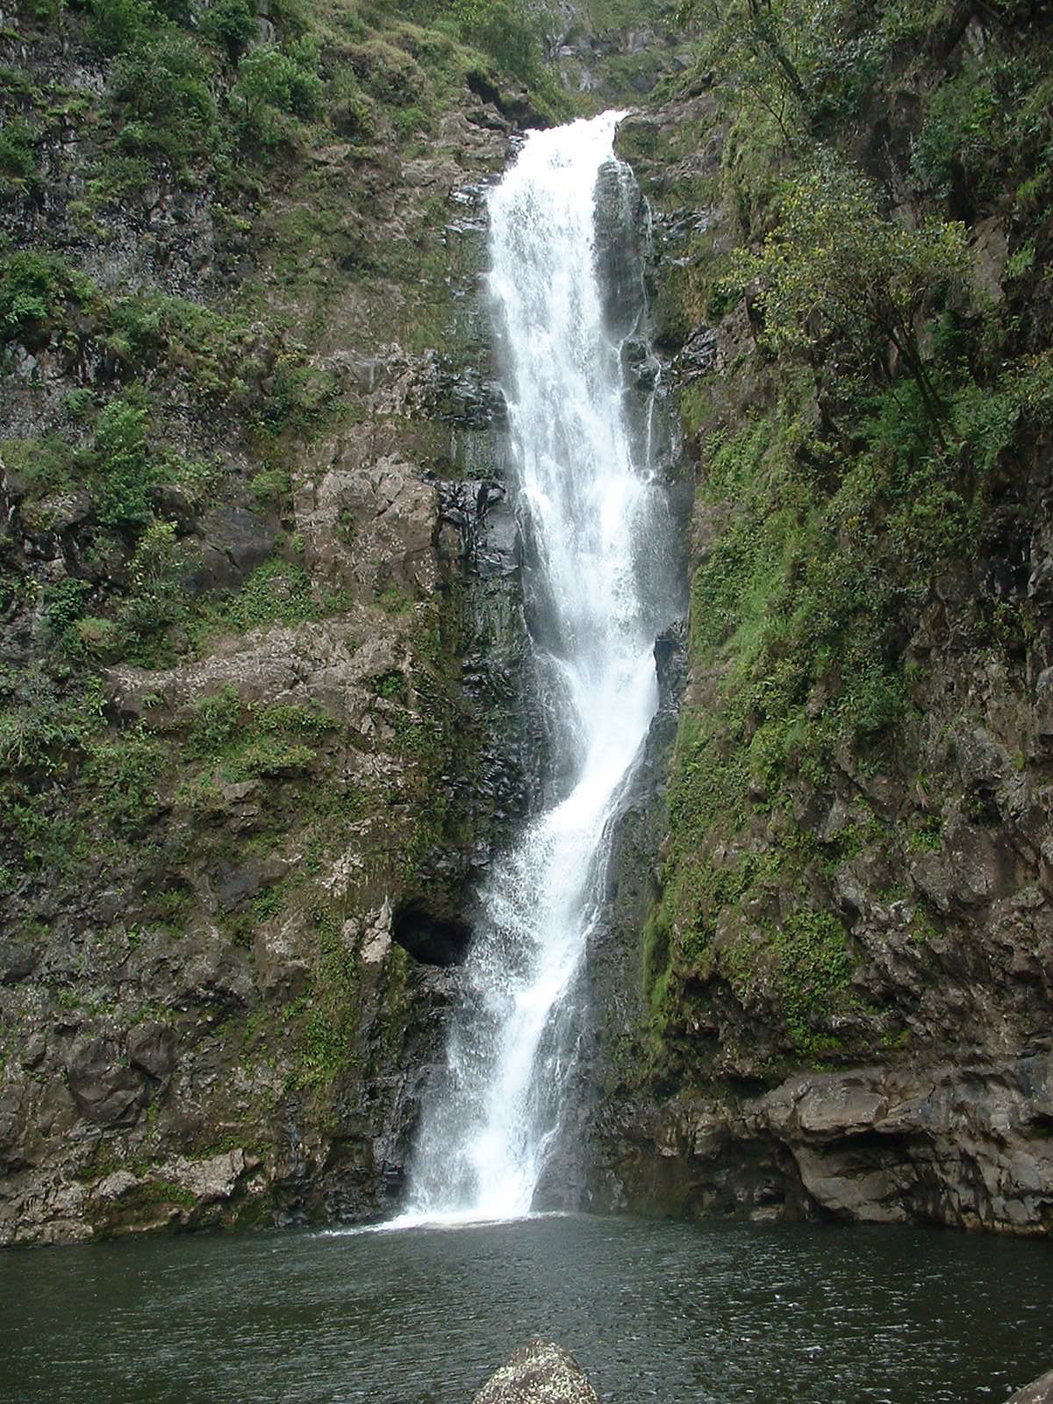

- Hoÿolauna – ka hapahä ÿaoÿao o ka pepa
- Ka welina (nä hoaÿölelo Hawaiÿi)
- Kou Inoa
- Paukü Pökole e pili ana iä ÿoe
- Haÿi i ka inoa o kou wahi pana

- Ke Kipa ‘Ana - ka hapalua o ka pepa ma ka ÿölelo Hawaiÿi e pili ana:
- I ka wä hea ÿoe i kipa ai i kou wahi pana (pöÿahia, ka lä ÿehia, ka hola ÿehia)
- Pehea ÿoe i hele ai i laila? (kaÿa, kalaiwa, hele wäwae, kaÿa ÿöhua)
- Pehea ke ÿano o ka lä? (pouli, wela, ua, makani)
- He aha ka mea i ÿike ÿia? (poÿe, hale, pua, kumu läÿau)
- He aha ka mea i lohe ÿia? (manu, kai, poÿe)

Kaha/Pena Kiÿi – E lawe i kekahi pepa no ke kaha a i ÿole pena kiÿi ÿana.
- E kaha.pena kiÿi ma luna o ka pepa 8 1/2” x 11”
- Hiki iä ÿoe ke kaha me ka penikala a i ÿole me nä peni.
- E kaha/pena i nä mea a pau äu e ÿike ai.

- Moÿolelo – hoʻokahi ÿaoÿao o ka pepa
- Aia i hea kou wahi pana?
  - Ma ka mokupuni hea?
  - Ma hea ma ka mokupuni? ÿäkau (north), hema (south), hikina (east), komohana (west)
  - Ma ka ÿaoÿao hea? – koÿolau (windward), kona (leeward)
  - Ma ka moku (district) hea? – (Koÿolaupoko, Waiÿanae, Hilo, Kona, etc.)

- Pehea ke ÿano o kou wahi pana? –
  - He aha ia wahi pana? – (kahakai, päka, heiau, hale pule, etc.)
  - Pehea ka ÿäina? – (ua, wela, maloÿo (dry), pulu (wet), etc.)
  - He aha ka moÿolelo e pili ana i kou wahi pana? – (he aha ka mea i hana ÿia ma laila i ka wä kahiko a me ka hana e hana ÿia nei i këia wä ÿänö?)

- No ke aha mai ÿoe i koho ai i kou wahi pana?
- He aha kekahi moʻolelo no kēia wahi pana?

- Mele – e haku i ʻehā lālani mele a ʻoi no kou wahi pana

- Kou Mau Manaÿo – ka hapahä o ka pepa
- No ke aha mai ÿoe e makemake ai i kou wahi pana?
- He aha nä mea maikaÿi ma kou wahi pana?
- He aha nä mea maikaÿi ÿole ma kou wahi pana?
- Pehea käkou e mälama ai i kou wahi pana?
- I ka wä e hiki mai ana, he aha kou makemake no kou wahi pana?

