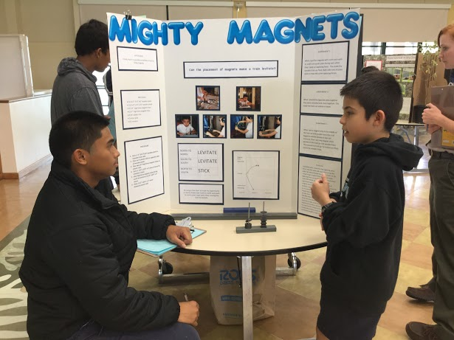
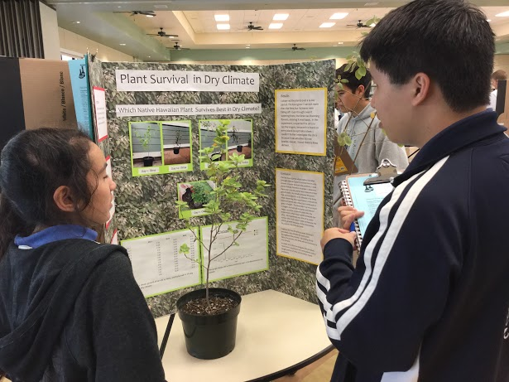

Kamehameha Schools Maui
Elementary Campus
4th and 5th Grade Science Fair Packet
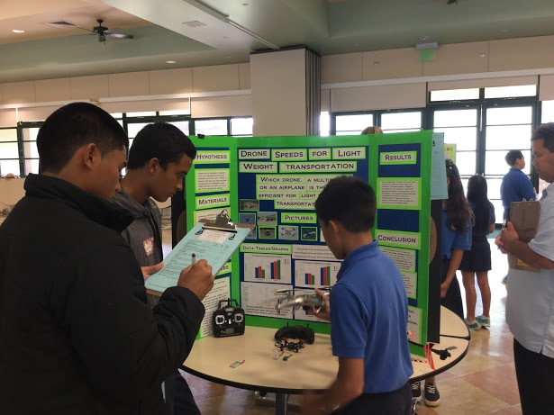
2015-2016
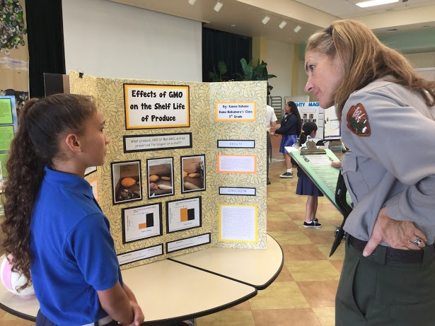
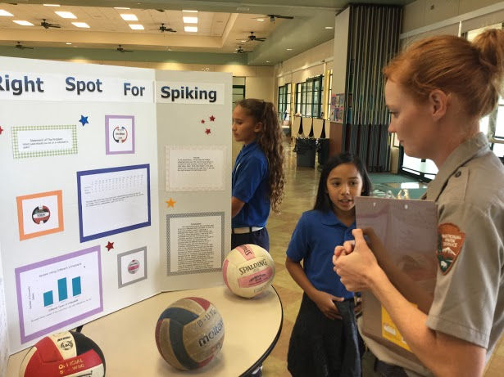

Parent Welcome Letter
Hōʻikeʻike ʻEpekema
Tuesday, March 8, 2016 -4:30pm to 6:30pm

Aloha Haūmana and Parents/Guardians,

We are pleased to announce that we will be hosting our second annual fourth and fifth grade Science Fair for the 2015-2016 school year. This will be an exciting event that encourages students to think and act like young scientists. This science event will provide our haūmana with opportunities to learn, understand and apply the scientific method. We hope you agree that the educational benefits are numerous as students develop skills in writing, oral presentation, creative thinking, and problem solving.

All of second trimester will focus on the different components of the scientific method and each student will have their own opportunity to learn, grow and explore new ideas. In class, we will focus on the development and analysis of the projects. The students will conduct their experiments at home. During this time your child will be expected to keep his/her science notebook at home and bring it to class on science days.

Each fourth and fifth grader is required to complete their individual project, groups are not allowed. Our goal is to have scientifically sound projects, which means they will be judged on accuracy and completion of the scientific process. Your support is the key to a successful project, by helping them gather materials and ensure the experiments are conducted safely. Please do not allow your involvement to extend any further in order to assure equity and promote student learning. The final project should reflect your child's individual effort, learning and design.
Please use this packet as a guide throughout the project, paying close attention to due dates. These packets are meant to stay home; we will also have all necessary resources in class. You can also find all this information and any updates on the Science Lab blog: http://blogs.ksbe.edu/jostenge Please review all safety rules carefully and submit the Student/Parent Agreement by Wednesday November 4th, 2015.

We look forward to an amazing Hōʻikeʻike ʻEpekema this school year.

Mahalo Nui Loa,

Kumu Jonathan Stenger Interim Po‘o Kumu Kula
Table of Contents

Parent Welcome Letter …………………………………………………………………….. 3

Table of Contents ……………………………………………………………………………... 4

Guidelines and Expectations …………………………………………………………….. 5

Project Information …………………………………………………………………………. 6

Safety Rules …………………………………………………………………………………. 7-8

Project Timeline ……………………………………………………………………………… 9

Scientific Method …………………………………………………………………………….. 10

Choosing a Topic ……………………………………………………………………..... 11-12

Experiment ………………………………………………………………………………...….. 13

Research ………………………………………………………………………...………..…13-14

Hypothesis ……………………………………………………………………………………... 14

Materials & Procedure ………………………………………………………….……. 14-15

Data (Collection) .……………………...………………………………………..…….......... 15

Results …………………………………………………………………………………………… 16

Conclusion ……………………………………………………………………………………... 16

Display Boards ……………………………………………………………………………….. 17

Criteria for Judging ………………………………………………………………………… 18

Student/Parent Agreement ………………………………………………………….…. 19

Guidelines and Expectations

Student Expectations
- Complete a scientific experiment using the scientific method.
- Plan, design and implement an investigation that incorporates fair testing and relates to real world examples.
- Collect data using tools to extend intangible observations.
- Identify what is being changed and what is being measured.
- Communicate regularly with Kumu on status of the project.
- Bring science notebook to every science class during the project.
- Learn something new and have fun doing it!

How Can I Help My Child With a Science Fair Project?
- Be positive!
- Allow your child to make mistakes that they can learn from.
- Help your child to examine what they are interested in, it could be he/she already does or would like to learn about. Observe and talk about things that are happening around them.
- Allow time for thinking and exploring alone.
- Ensure deadlines are met.
- Communicate any concerns or incidences that affect the student’s experiment.
- Provide necessary materials for student to conduct an accurate experiment.
- Divert any unnecessary pressure, this is meant to be a education and fun learning opportunity.
- If possible, be sure to attend the science fair event to celebrate your child’s achievement and success.

Project Information

Student/Parent Agreement
The Student/Parent Agreement establishes that the student has the approval of the parents/guardians and Kumu to begin his/her science fair project. The completed Student/Parent Agreement form must be reviewed and signed by each participant and their guardian before turning it in to Kumu Stenger by Wednesday November 4th, 2015. The form can be found on the last page of the packet.

Science Notebooks
The science notebooks are where all the information will be recorded. Please keep neat and accurate notes. Don’t scratch out or erase any of your work, just put one line through the middle of the work you no longer want to keep. Students will be given colored tabs that will indicate the location of each section of their project.

iPads
This year we will incorporate the use of the iPads in the science fair projects. Each student will have the opportunity to present his or her data and results using the iPad. Which method (app) the student choses depends on they type of data and how he/she wants to display it.

Backboard Display
The display board is designed to inform judges and visitors. Make it clear and eye-catching. Make sure your headings stand out. You want to include important parts of your investigation. We are happy to announce that a display board will be provided for each child this year. If it is lost or misplaced, it is the child’s responsibility to replace it with a board of the same dimensions (white 36”W x 46”H tri-fold board).

All display boards must be completed and turned into their Homeroom by Tuesday, March 1st, 2016. If you have any questions, please contact Kumu Stenger, (808) 572-3254, email: jostenge@ksbe.edu

Event Judging
The Science Fair is a celebration of science; an opportunity to showcase your child’s capabilities, learning and bright ideas! To promote this high-energy showcase there will be 24 judges’ choice awards for the top preforming projects. The selections are awarded based on scientific reasoning, testing, and presentation for the experiment. Judging will take place the morning of the Science Fair event, during school hours. Your child must be present and present in front at least 3 judges to qualify for receiving an award.

SCIENCE FAIR SAFETY RULES

- ALL PROJECTS MUST BE APPROVED BY THE TEACHER BEFORE BEGINNING TO TEST.

- The project to be presented must be the work of the student and must concern itself with a single subject.

- Students are expected to keep a step by step notebook recording the development of the project, including references, original data, etc. Original data are of great value in all projects.

- No exhibit should be more than 40” in width. No oversize projects are allowed to the exhibit. Wall space for posters, tape, tacks, etc. is not available. Students should construct their exhibits so that wall space is not necessary.

- No live vertebrate animals may be exhibited at the fair (models or photographs should be used instead).

- Projects may not involve experiments on any living creatures that result in their death, altered state or mutilation (i.e., pesticide effectiveness).

- Students should avoid doing experiments involving bacteria cultures.

- No controlled substances will be exhibited.

- No dangerous or combustible chemicals may be displayed at the fair. Rockets or engines must not contain fuel. All chemical displays must have the contents clearly marked on the container and be presented in a safe manner.

- No open flames will be permitted.

- If eye protection is necessary, student experimenters must wear safety goggles and follow standard safety practices. Parent supervision may be required for some projects.

- All projects using household electricity must conform to standard wiring practices and safety.

- Expensive or fragile items may not be displayed. Valuable items essential to the project should be simulated or photographed.

- Collections (i.e. minerals, shells, feathers, etc.) should be protected with a covering of plastic wrap.

- Items to be displayed in front of display board must be adequately secured (i.e., batteries, wire, switch and motor secured to a piece of plywood and placed in front of board).

- Carefully pack all materials when transporting to and from the Science Fair.

- After a project is inspected for compliance with these rules and regulations no changes are permitted.

- Student names should be posted at the back of the display board, using the label provided.

For any questions/clarifications, please contact Kumu Stenger.

Project Timeline

Due dates vary based on student’s Homeroom class. Each due date represents when your child has science class and his/her work is due on that day.

Section | 4K | 4D | 5N | 5M
Student/Parent Agreement Due | 11/3 | 11/4 | 11/4 | 11/3
Research Due | 11/17 | 11/18 | 11/18 | 11/17
Hypothesis Due | 11/23 | 11/30 | 11/30 | 11/23
Procedure Due | 12/9 | 12/10 | 12/10 | 12/9
Testing Experiment | 1/11 | 1/12 | 1/12 | 1/11
Results Due | 1/28 | 1/29 | 1/29 | 1/28
Conclusion Due | 2/17 | 2/18 | 2/18 | 2/17
Presentation Boards Due in Homeroom | 3/1 | 3/1 | 3/1 | 3/1
Science Fair Event @ 4:30-6:30 pm | 3/8 | 3/8 | 3/8 | 3/8

SCIENTIFIC METHOD

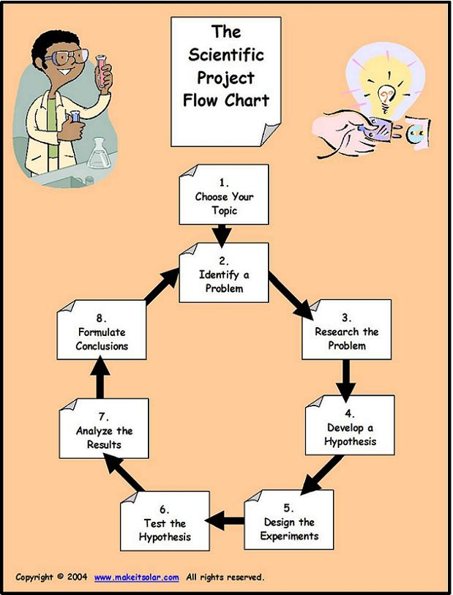

Choosing Your Topic

4th Grade: Since this is your first year conducting a Science Fair experiment, you will be able to choose a topic from a few categories. Make sure you pick something that you are interested in. The list below is meant to help you come up with ideas, so you can choose something that is not listed; as long as it falls under one the these categories.

PLANT SCIENCES
Anatomy
Botany
Agriculture/Agronomy
Development
Ecology
Genetics
Photosynthesis
PHYSICS
Energy
Matter
Magnetics
Electromagnetics
Optics
Lasers

5th Grade: Now that you have already successfully completed a Science Fair project last year you will again have the choice of your topic. Below are some ideas that can help you think about what you want to test and learn about. Make sure it is something that interest you and you want to spend your time learning about. If you are not sure about a specific topic, research it to see if it is of interest.

Life science:
This category includes animals, plants, and humans. Here are some topics that you could look into to see if you are interested.

ANIMAL SCIENCES
Animal Husbandry
Development
Ecology
Physiology
Systematics
Other

PLANT SCIENCES
Anatomy
Botany
Agriculture/Agronomy
Development
Ecology
Genetics
Photosynthesis

Physical Science:
This category is about testing how things work. Below are some topics that you could look into.

ENERGY
Electricity

ENGINEERING:
Robotics

CHEMISTRY
Properties of matter
PHYSICS
Magnetics
Electromagnetics
Optics
Lasers

ENERGY & TRANSPORTATION
Vehicle Development
Renewable Energies

Earth and Space Science:
This category includes earth and even space. Below are some topics that you might find interesting.

EARTH & PLANETARY SCIENCE
Geology
Climatology
Weather
Geochemistry
Mineralogy
Paleontology
Biomimicry

ENVIRONMENTAL SCIENCES
Air Pollution and Air Quality
Soil Contamination and Soil Quality
Water Pollution and Water Quality

ENVIRONMENTAL MANAGEMENT
Oceanography
Ecosystems
Environmental Science
Land Resource Management,
Forestry
Recycling, Waste Management

CHECKLIST TO SEE IF YOU HAVE A GOOD QUESTION
____ Am I interested in the answer?
____ Does it meet Guidelines? (no models, no harming animals, etc.)
____ Is it something that requires an experiment to answer?
____ Can I get the materials necessary?
____ Can I find research on the topic?
____ Can I do all or most of the project on my own?
____ Can the results of the experiment be measured in some way?
____ Will my parents and teacher approve of it?

Experiment (Problem)

What is it: After you know the topic you want to investigate, you have to state the problem. This should be one sentence in the form of a question. There are three parts to forming a high-quality experiment:
- Independent variable: The thing that is changed.
- Dependent variable: The thing that is measured.
- Control variable(s): Everything that is kept the same in each test.

How it can be used:

What is the effect of __________________ on ___________________?
How does the ______________________ affect _____________________?
Which/What ____________________ (verb) _____________________?

Research

What is it: After you have picked your category and have designed your problem. This section is to help you research your problem as much as possible, remember your will be the leading specialist on your topic, so you should know as much as possible about it. The best way to become a specialist you must read, watch science videos, and even talk to others about all the different parts of your experiment, but don’t forget to keep track of what you learned. Also, include what you already knew about your topic.

You can look at books or the Internet and interview other specialist. Make sure you have at least three different sources from your research. This will make sure your looked at all angles of your experiment.

How it can be used:
Paragraph 1
I picked this topic because…
I am interested in _______therefore I picked ________as my experiment.
Before doing this research, I knew that….

Paragraph 2
In my research, I found that…

Paragraph 3
Another important fact about my topic is…

These fit into both paragraph 2&3
_____(topic)____ is important to ___________because…
<citation> says that….
This connects to my experiment because….

Hypothesis

What is it: A hypothesis is an educated prediction, this section is where the scientist uses its knowledge about the topic, from research, to make a statement about what he/she think the results will be. The hypothesis says what you think will happen and why you think that will happen.

There are three sections to forming a high-quality hypothesis:
- Independent variable: The thing that is changed.
- Dependent variable: The thing that is measured.
- Reasoning: An explanation of the relationship and why the independent affects the dependent variable.
Feel free to use this sentence starter below to help you build your hypothesis…

How it can be used:
If…(independent variable)..then..(dependent variable)., therefore…(reasoning)
If….then…..because…(reasoning, my research shows)
Materials & Procedure

What is it:
Materials should be bulleted; a detailed and descriptive listing of all the materials used in the experiment.

Procedure:
Think about what and how I am going to test my experiment. Then write down each step in order leaving nothing out. Review my list to make sure my experiment can be by someone else using my steps. Make sure to number each step. Also, a data sheet (table and/or chart where you record your data) needs to be made as part as the procedure. Show Kumu Stenger and get his signature (without his signature, you CAN NOT conduct your experiment). Each child will need to have his/her experiment reviewed before conducting an experiment. A signature by Kumu Stenger in the student’s notebook will serve as the go-ahead to test the experiment.

How it can be used:
Materials:
List the Materials that you will need for your science experiment here:
- ___________________________
- ___________________________
- ___________________________
- ___________________________
- ___________________________
- ___________________________
- ___________________________
- ___________________________

Procedure:
List the steps that you have to do in order to perform the experiment here:
- ______________________________________________________________________________
- ______________________________________________________________________________
- ______________________________________________________________________________
- ______________________________________________________________________________
- ______________________________________________________________________________
- ______________________________________________________________________________
(add more steps if needed)

Just as above, the procedure should be step by step and numbered. Include what data you will be collecting and how the data will be recorded.

Data (Collection)

What is it: This section shows what you observed during the experiment. It will include all the data from the experiment. This could be observation notes, measurements or a combination of both. The type of data will depend on each experiment. Make sure you take a lot of pictures throughout the experiment!

How it can be used:
This is a table where the data is collected during the experiment. Make sure each side of the table is labeled.

Results
What is it: Taking the data that you gathered, the results are a summary of the data. This is where you take your data and turn it into charts, graphs, and an explanation to show what you observed. Don’t worry if it didn’t turnout the way you expected, that is what science is all about, learning something new. Your explanation should be a paragraph that explains the results of your experiment.

How it can be used:
Charts and graphs based on your data. Each experiment will have different looking charts and graphs. Make sure everything is labeled so the reader can understand what he/she is looking about without an explanation. Below are some sentence starters that could help you begin writing your results.

In my experiment, I found that…
The more/less..(variable), the more/less it ..(result)..
The …that grew more had……
The….was change, which resulted in ….
In my experiment, I was….that….
I noticed(or observed)…
In my experiment, I expected that the…
These test (test__ & __), produced similar results, while the __test produced, a much larger result.

Conclusion

What is it: The last section of an experiment is a review of the whole project and shows what you learned from your experiment. Your conclusion should include these five parts:
- Restate your experiment and examine the outcome compared to the hypothesis.
- A statement on whether or not your hypothesis was correct and explain why this is so.
- Assess your data, by explaining what piece of information told you that your prediction was right or wrong.
- Discuss any problems encountered during the procedure.
- Offer another way that you could further research or test this experiment.

How it can be used:
The results of this experiment are important because…
Based off of my findings, another experiment I could test is….
This is important because…

Display Boards

The display board is designed to inform judges and visitors. Make it clear and eye-catching. Make sure your headings stand out. You want to include important parts of your investigation. Each child will receive one display board to take home. If it is lost or misplaced, it is the child’s responsibility to replace it with a board of the same dimensions (white 36”W x 46”H tri-fold board). The format of the display board should be as follows.

All display boards must be completed and turned into their Homeroom by Tuesday, March 1st, 2016. If you have any questions, please contact Kumu Stenger,
(808) 572-3254, email: jostenge@ksbe.edu

Conclusion
Hypothesis
Title
Statement of the Problem
Materials

Pictures

Data: Graphs/Diagrams

Procedure
iPad: Results

Criteria for Judging

 | Liko  (Emerges) |  | Pua  (Meets) |  | Hua  (Extends)
Problem/Hypothesis  Problem is new/different/meaningful/researched. Hypothesis is testable. | 1 | 2 | 3 | 4 | 5
Experimental Design/Procedure  Procedure is appropriate and thorough. Steps of procedure are listed, and sequential. Variables have been identified. Controls, when appropriate, are in place. Safety issues have been addressed. | 1 | 2 | 3 | 4 | 5
Data Collection  Proper use of measuring. Adequate number of trials/adequate sample size. Appropriate use of photos/charts/graphs to display data. | 1 | 2 | 3 | 4 | 5
Analysis  Conclusions supported by data. Sources of error have been considered. Attempts have been made to answer “why” or “how” | 1 | 2 | 3 | 4 | 5
Visual Display  Board is neat, attractive, and creative. Spelling and grammar are correct. Graphs/charts are properly labeled. | 1 | 2 | 3 | 4 | 5
Interview  Student displays subject knowledge from investigation, research and experiment. Student can extrapolate from experiment. Student speaks clearly and explains the project well. | 1 | 2 | 3 | 4 | 5
Level of Difficulty/Creativity (age appropriate)  Problem is conceptually intricate/requires extra effort/involves a creative approach. | 1 | 2 | 3 | 4 | 5
Total: /35

Student / Parent Agreement
Kamehameha Schools Maui Elementary Campus
2015- 2016 Hōʻikeʻike ʻEpekema
Tuesday, March 8, 2016 4:30pm to 6:30pm

-Student Agreement-

I, , agree to complete a science fair project on
(Name of Student)

. I also agree to do my own
(Science Experiment-Problem)

work and follow the above guidelines for Science Fair projects. I have read the Science Fair Rules and have received the packet. I understand what is expected of me, and will meet the project due dates; but most of all have fun and learn!

________________________________________________ ____________________
[Student’s Signature] [Date]

-Parent or Guardian Agreement-

I agree to encourage my child’s participation in the Science Fair by providing guidance and support when needed. I will ensure that my child completes his/her project by the due date. I approve my child’s project topic and ensure my child will be able to acquire the necessary resources to complete his/her experiment.

My signature below certifies that I have read all Science Fair Rules and Guidelines.

________________________________________________ ____________________
[Parent or Guardian Signature] [Date]

-Kumu Section-
Science Experiment Date Received ________________
Student Signature
Parent Signature
____________________________________________
[Kumu’s Signature]

