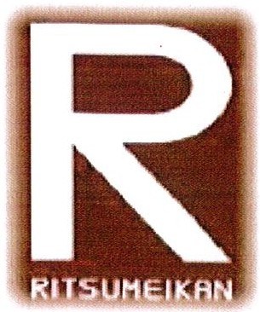
Global Summit 2016
Car Wash

Saturday, December 12, 2015
8:00 am – 12:00 noon
Kamehameha Elementary Bus Ramp
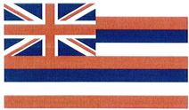
To benefit: MS Global Connections students traveling to the Middle School Global Summit in Kyoto, Japan Jan. 25 – Feb. 1, 2016

