Tagxedo Instructions

- Create a slide in PowerPoint with your FIRST NAME only
- Choose font size for your name large enough so your name covers at least 1/4 of your PowerPoint Slide.
- Chose File > Save As Pictures
- Name your document your FIRST NAME to the desktop
- Close PowerPoint
- Go to www.tagxedo.com
- Click on Create
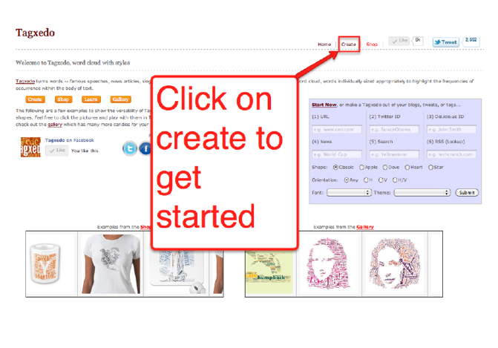
- Click on Load, Type your FIRST NAME into the text box and click submit.
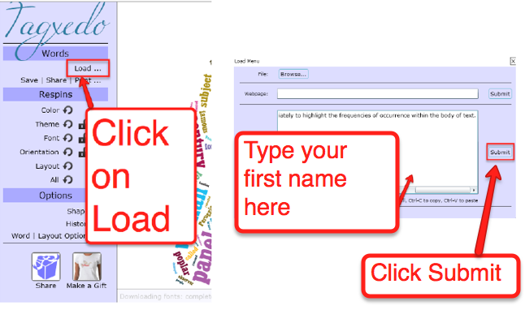
- Click on the little triangle next to Shape and then Add Image
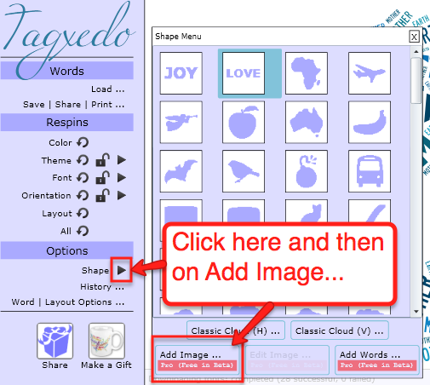
- Upload Slide1 from the folder named “your name” on your desktop. Click Okay.
- Click Accept
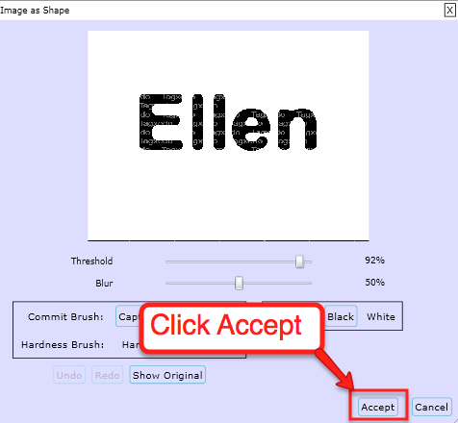
- Voilla!
After you customize your Name, Save it:

- Click on Save Share Print
- Make sure you’re on the Image tab and choose 2MP JPG
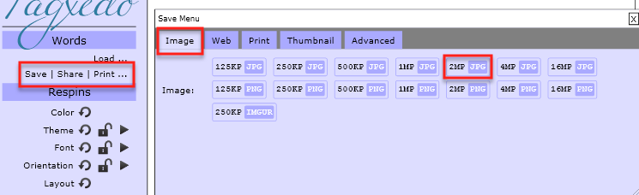
- Save the Jpeg as “your name” to your desktop. Close the pop up window.

