Prince Jonah Kuhio Kalanianaole Day
Prince Jonah Kuhio Kalanianaole Day, also known as Prince Kuhio Day, is a state holiday in Hawaii. It is observed on March 26 every year and honors Prince Jonah Kuhio Kalanianaole, one of the best-known leaders in Hawaii’s history.
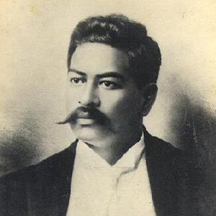
Prince Jonah Kuhio Kalanianaole. Courtesy Hawaii State Archives
What do people do?
Prince Kuhio Day celebrations are held in Hawaii on or around March 26. The celebrations vary in duration and are celebrated by festivals and parades. There are celebrations in honor of Prince Kuhio that last for one month in March, as well as week-long festivals that showcase Hawaii’s cultural practices, customs, and traditions.
Festivals may feature statewide canoe races, cultural demonstrations, and luaus. Health organizations actively participate in the month-long Prince Kuhio celebrations as a way of increasing people’s awareness on health issues. Many people also commemorate Prince Jonah Kuhio Kalanianaole Day by attending special services at Oahu’s Royal Mausoleum, where Prince Kuhio is buried.
Background
Prince Jonah Kuhio Kalanianaole Day remembers his life efforts to improve people’s lives in Hawaii. Prince Kuhio was born on the island of Kauai in 1871. He was Queen Liliuokalani’s cousin and she named him to be an heir to the throne so he was given the title of “prince”. He studied in California and at the Royal Agricultural College in England. He was 24 years old when he joined the Royalist uprising against the new republic in 1895 and was captured and convicted of treason.
Prince Kuhio later worked with the industrialists who overthrew the monarchy, believing that cooperation would bring political power that could help his people more than resistance would. He ran for the office of territorial delegate to the US congress and won. He was also re-elected 10 times. He focused on developing Pearl Harbor and Honolulu Harbor, regular mail delivery and the “back to the farm” movement during his tenure.
He is best remembered for his successful effort to get congress to pass the 1920 Hawaiian Homes Commission Act to provide homesteads for native Hawaiians. He also introduced a bill in 1919, which requested that Hawaii be admitted into America as a fully fledged state. Hawaii became the 50th state in 1959. Prince Kuhio died in Waikiki, near Honolulu, on January 7, 1922, and a holiday was created to honor him in 1949.

